

Project Title - Optimizing Retail Stock Levels Through AI-Powered Demand Prediction

Submitted in partial fulfillment of the requirements for the award of the
degree of
Master of Science (Data Science) MSc (DS)
By
Student Name: Mohit Yadav
Enrollment No: 024MSD110076
Under the guidance of
Guide/Mentor Name: Vikas Kumar Atray

Certificate

BONAFIDE CERTIFICATE
Certified that this project report titled “Optimizing Retail Stock Levels Through AI-Powered Demand Prediction” is the bona fide work of Mohit Yadav, Reg. No.: 024MSD110076, who carried out this project work under my supervision.

GUIDE SIGNATURE STUDENT SIGNATURE

Date: 10/05/2026 Date: 01-05-2026
Place: Chandigarh Place: Chandigarh

Declaration
I, Mohit Yadav, hereby solemnly declare that the project report titled " Optimizing Retail Stock Levels Through AI-Powered Demand Prediction” submitted in partial fulfilment of the requirements for the award of the degree of Master of Science (Data Science) is my original work.
I further declare that:
- This project has been carried out by me during the academic year 2024 - 2026 under the supervision of Vikas Kumar Atray.
- The work has not been submitted previously to any other university, institution, or examination body for the award of any degree, diploma, or certification.
- All sources of information used in this report have been duly acknowledged and referenced in accordance with academic ethics and plagiarism norms.
- The data presented in this report is authentic to the best of my knowledge and has not been fabricated or manipulated.
- I understand that if any part of this declaration is found to be false, my project may be rejected and disciplinary action may be taken as per institutional rules.
Place: Chandigarh
Date: 01-05-2026
Student Signature:

Student Name: Mohit Yadav
Enrollment No: 024MSD110076

Acknowledgement

I would like to thank Vikas Kumar Atray for his regular guidance, feedback and support for the project. He assisted in shaping both the technical and academic aspects of the project.
I would also like to thank the teaching faculty of the department for creating an academic space, technical environment and idea space to carry out this project. Their courses in data science, statistics, machine learning and system development provided the necessary foundation for the project.
Thank you to the university for granting me the opportunity to develop a project that is relevant for a business and implementing data science. I also wish to thank my family and friends for their encouragement, support and patience during the period of this project.

Abstract / Executive Summary

This project is an applied data science project to automate retail inventory management with AI-based demand forecasts. The research uses the Corporacion Favorita grocery sales data to predict daily store-level demand of three product families: Beverages, Dairy, and Grocery I. The goal is to forecast short-term demand, and convert this into inventory-related decisions such as safety stock level, reorder point and optimal order quantity. The study starts with cleaning various raw files such as sales, item, store, transactions, oil price, and holiday. A clean daily analytical data set is generated and described and visually presented. Several models are evaluated based on MAE, RMSE and MAPE using chronological train-test split, including seasonal naive, moving average, lag-based linear regression, ARIMA and Prophet. The best model is selected for inventory recommendation and the simulation of reorder warnings. The deliverable includes report-ready numbers, tables of error metrics, an HTML dashboard, and an example of how predictive analytics can assist in stock planning for retail.

Table of Contents
Contents
Certificate 0
Declaration 2
Acknowledgement 3
Abstract / Executive Summary 4
Table of Contents 5
Chapter 1: Introduction 8
1.1 Project Background 8
1.2 Problem Statement 9
1.3 Project Goals 9
1.4 Project Scope 9
1.5 Existing System Overview 10
1.6 Proposed System Overview 10
1.7 Technologies Used 10
1.8 Why Demand Forecasting is important in Retail 10
1.9 Intended Audience 11
1.10 Academic Contribution of the Work 11
1.11 Deliverables of the Project 12
Chapter 2: System Study 14
2.1 System Study Introduction. 14
2.2 Similar Systems Review. 14
2.3 Comparative Analysis of the Current methods. 15
2.4 Software Development Model 15
2.5 Relatable Frameworks and Libraries. 16
2.6 Research Gap 16
2.7 Methodological Rationale 16
2.8 Dataset Study 17
2.9 Research of Forecasting Libraries. 18
2.10 Gap between Forecasting and Action of Inventory. 18
2.11 Baseline Methods Study. 19
2.12 Classical Forecasting. 20
2.13 Study of Business Forecasting Tools 20
2.14 Study of Feature Engineering 21
2.15 Study of Inventory Planning Concepts 22
Chapter 3: System Analysis 24
3.1 System Analysis Overview 24
3.2 Functional Requirements 24
3.4 Feasibility Study 25
3.5 System Architecture 25
3.6 Analytical Assumptions 25
3.7 Data Requirements 25
3.8 Constraints and Risks 26
3.9 System Inputs and Outputs. 26
3.10 Requirement Prioritization 27
3.11 Data Quality Considerations 28
3.12 Model Evaluation Requirements 29
3.13 Reporting Requirements 29
3.14 Risk Mitigation Strategy 30
Chapter 4: System Design 32
4.1 Design Overview 32
4.2 Module Design 32
4.3 Forecasting Design 32
4.4 Inventory and Reporting Design 33
4.5 Design Principles 33
4.6 Data Flow Design 33
4.7 Dashboard Design 34
4.8 Diagram Design Rationale 34
4.9 Design for Reproducibility 35
4.10 Design for Interpretability 35
4.11 Design for Extensibility 36
4.12 Design for Reporting 37
4.13 Design Limitations 38
Chapter 5: System Implémentation 40
5.4 Module-Wise Implementation 40
5.5 Major Algorithms and Logic. 41
5.7 Preprocessing Implementation Details 42
5.8 Forecasting Implementation Details 43
5.9 Implementation of the Inventory Simulation Details. 43
5.10 Reporting Implementation Details 44
5.11 Code Organization 44
5.12 Managing of Constraints at Run time. 45
5.13 Forecast Outputs. 46
Chapter 6: Testing 47
Chapter 7: Results & Discussion 48
Chapter 8: Conclusion & Future Scope 49
Chapter 9: References 50
Chapter 10: Appendices 51

Chapter 1: Introduction

Project Background

Proper management of inventory in a retail environment impacts profits, service levels and customers. Retailers regularly make inventory planning decisions about how much to stock, when to restock and how to manage inventory levels to avoid stock-out and over-stocks. These choices are challenging when demand is uncertain and affected by promotions, holidays, foot traffic, seasonality and category-specific demand patterns. In these circumstances, data-based forecasting can help to improve forecasting accuracy.
The purpose of this project is that forecasting should not be a stand-alone analytical exercise. In practice, the usefulness of a forecast is in what it can do: anticipate when to replenish stock, highlight category performance, improve stock stability, and support decision-making. As such, this project is designed as an end-to-end process from the transactional data to inventory recommendations, stock alerts and reporting.
This project works with the Corporacion Favorita grocery sales dataset, which has emerged as a helpful comparison for retail forecasting as it includes not just sales, but also metadata about the stores, the families for the items, holiday events, oil prices and daily transactions. Rather than trying to model all stores and all items, in this study we focus on store 1 and three families Beverages, Dairy, and Grocery I. This makes it easier to understand and digest for a master's project, without losing the complexity required for good forecasts.
The other reason for limiting the scope is educational. Student projects often have broad scope but thin, not thick, explanation. By contrast, the more focused and justified implementation allows us to explain the rationale behind preprocessing, feature engineering, model comparison and inventory policy design. This combination of theory and practice is the focus of this report.
Another contribution of the project is a response to the common deficiency in forecasting research: ending with accuracy measures. Although comparing models is important, a stock planning system needs to go beyond that by providing an interface to stock decisions. As such, this project goes beyond forecasting to calculating safety stock, reorder point, optimal order quantity, stock simulation, and alerts.

Problem Statement

Stores are often faced with either excess stock or out-of-stock situations due to the uncertain nature and volatile nature of future demand. If managers rely solely on judgment or average demand, it results in less-than-optimal stock allocation. This project overcomes this problem by developing a demand forecasting and stock planning process for a chosen retail aspect.

Project Goals

1. To gather, prepare, and merge several raw data sets about retail to create an analytical table.
2. To engage in exploratory analysis of sales behaviour of selected families.
3. To assess forecasting models using a chronological approach.
4. To find a forecasting model suitable for short-term demand forecasting at the family level.
5. To translate forecasted demand into safety stock, reorder point and reorder advice.
6. To allocate stock and issue reorder prompts for the holdout period.
7. To generate visual and tabular reports for application in report writing and business discussion.

Project Scope

The Corporacion Favorita dataset consists of numerous stores and product families. To have a technically significant and academically justifiable project, this work focuses on store 1 and three product families: Beverages, Dairy and Grocery I. This scope retains sufficient variability in demand to investigate but allows for in depth implementation and analysis in the time available for a master's project.

Existing System Overview

In traditional settings, stock planning is typically based on manual spreadsheets, historical averages, or professional judgment. These methods generally do not account for dynamic demand signals like promotions, seasonality, holidays and other short term variations. This naturally leads to reactive replenishment.

Proposed System Overview

The system will combine raw data, build a clean data set for analysis, compare various forecasting models, identify the best model, then translate the model into inventory recommendations. It also forecasts stock movements in the holdout period and produces alerts and dashboards for review and reporting purposes.

1.7 Technologies Used

The project is implemented in Python, Pandas, NumPy, Matplotlib, Statsmodels, Prophet, Jupyter Notebook, Git, Markdown and HTML. These tools are used for data manipulation, model evaluation, reporting and project management.

1.8 Why Demand Forecasting is important in Retail

Retail demand forecasting is important for short planning horizons and repeated decisions. A store may decide its replenishments daily or several times a week, and if it makes a mistake in its forecast and repeats it, the effect will be noticeable across product lines. The policy for a product with variable demand differs from the policy for a product with constant demand, and a system that does not take this into account will most likely either overstock or understock at least one product class.
In this project, forecasting is considered as an aid to planning, not a mathematical exercise. The forecast is only half the answer. The bigger part of the solution is the link between forecasted demand and inventory actions (e.g. safety stock and reorder point). This is important for business users since it provides a solution to the question of what to do with the demand prediction.
The choice of product families also makes forecasting interesting. Grocery I has a high volume of demand and is therefore important. Beverages can be variable because of changing consumption over days, months and events. Dairy is important for operations because frequent replenishment and shelf-life can influence planning. These two families offer sufficient diversity for a meaningful study.

1.9 Intended Audience

The users of this project are the student or analyst who operates the notebook and pipeline. But the target beneficiary is more general. A store manager, retail planner or procurement team could use this type of output to identify which categories need more focus and which categories will be triggered to replenish during the planning period.
The project also benefits academic reviewers as the process is transparent. The report, notebook, scripts, figures and output tables all reference the same workflow. This makes it possible to check that the code is running properly and that the report description is based on the generated reports.
The design could be scaled up by a future business user by including more stores, families, supplier lead-time rules, purchase costs, and warehouse capacity. The current project should therefore be seen as a proof-of-concept project that illustrates the workings of the system on a limited scope.

1.10 Academic Contribution of the Work

1.14 Academic Contribution of the Work is a critical part of this project because the academic contribution is to link the data preparation, the forecasting, the evaluation and the inventory logic into a repeatable workflow. This consideration shaped the planning and documentation of the system. Rather than just thinking of the project as a model, the workflow was designed to accommodate an academic reviewer or business user who needs to understand how the data goes from source files to recommendation.
In terms of how the project is implemented, this aspect shows up in the way preprocessing, model evaluation, inventory logic and reporting are separated. There is a clear separation of concerns and this makes it easier to interpret the results. It also simplifies the project's code, as future changes to one stage do not require rewriting other stages.
The benefit of using this design approach is that it leads to a stronger academic submission. The reader can see the justification step by step, can see the outputs, and can see the discussion in the report linked to the implementation. This is particularly important for a project at MSc level as the assessment is not just related to the code working, but to the design being justified and discussed.
In the thesis report, this also ties the technical work to the report layout. It demonstrates that 1.14 academic contribution of the work was not an add-on, but part of the plan. This makes this chapter better because it discusses the motivation for the implementation rather than just the output.

1.11 Deliverables of the Project

Deliverables of the Project is important in this project because the project deliverables include code, notebook explanation, generated figures, evaluation tables, inventory recommendations, stock alerts, dashboard output, and this formatted report. This point influenced the system design and documentation. Rather than view the project as a simple model development exercise, the design involved the expectations of a reviewer or business analyst who needs to understand the data flow from raw data files to a recommendation.
This shows in the technical design through the segregation of the preprocessing, model evaluation, inventory rules and reporting. Each step has a particular role and this helps to avoid confusion when the outcomes are interpreted. It also makes the project more extensible because when the project changes, you need not re-write all of the other stages.
The benefits of this design are that it leads to a more justifiable academic project. The reader can see the reasoning as it proceeds, look at the results and put the explanation into context with the implementation. This is particularly relevant in an MSc project since the assessment is not only on the code but also the justification of the approach and its communication.
When the project is submitted, the discussion also links the technical report to the report structure. It demonstrates that deliverables of the project was integrated into the project rather than tacked on later. This makes this chapter stronger because it not only explains what is done, but also why.

Chapter 2: System Study

2.1 System Study Introduction.

It has been years of research in operations and retail analytics; nevertheless, it still does not seem to be a completely resolved issue. Classical techniques such as moving averages or ARIMA are still employed and this may initially look counter-intuitive. However, in reality, they make a gift of something significant a simple and explainable base line. When these are not defeated by a complex model, then perhaps it is not really useful. Transparency can at times be more important in academic writing than the numbers of accuracy.

2.2 Similar Systems Review.

At the same time, retail forecasting has changed a lot. And it is no longer just about the sales in the past. The real demand appears to be based upon numerous external factors such as time of the year, promotion, even how busy the store was at that time of the year. This has been demonstrated by some large competitions and studies, where the inclusion of additional features led to a significant improvement in performance.

Prophet is sort of between more statistical models and more engineered systems. It processes trend and seasonality easily explained, which may be the reason many business teams are fond of it. Not always the best, but usually good enough and more easily justifiable. This project is no exception as it functions as an intermediate point in terms of comparing various approaches.

Here, feature-based machine learning techniques also seem to make sense. In the retail industry, the sales of yesterday or the trend of last week usually tells much about today. Even simple regression model can be used to extract helpful signals using lag features and rolling averages. When holidays or counts of transactions are also added to models, then models may now be regarded more as practical than theoretical.

2.3 Comparative Analysis of the Current methods.

Learning algorithms such as LSTM are the ones that are frequently discussed. They are able to automatically capture temporal dependencies, which is potentially powerful. However, they require additional data, additional computations, and additional tuning. In a regulated educational system, they are not necessarily feasible to be implemented fully.
In this project therefore, these models are not given primary attention, but as extensions. It might be a bit of a limitation, yet in actual sense it makes the work more explainable. It happens that when experimenting with too many sophisticated models, the clarity is lost and confusion ensues.

2.4 Software Development Model

System perspective: in this project a rigid linear process is not followed. The problem of data science does not reflect real life much like that. You explore data, and realize that some aspect is missing, rewind, correct it, and re-run model. It is rather looping than straight pipeline.
It is due to this that an iterative approach was pursued. The influence of preprocessing, analysis, modeling and evaluation on one another continues. It might appear messy here and there, but is more akin to the actual occurrence of projects.

2.5 Relatable Frameworks and Libraries.

Pandas was used to handle and combine data, NumPy to perform numerical operations, Matplotlib to display report-ready graphics, Statsmodels to work with ARIMA, Prophet to build decomposable forecasts, and Jupyter Notebook to provide an analytical explanation step-by-step. These tools have been selected based on the fact that the tools are widely accepted, accessible, and suitable to an applied analytics project.

2.6 Research Gap

A frequent limitation to the student forecasting project is that the projects end with the presentation of accuracy measures. This project tries to bridge that gap by proceeding with model evaluation to inventory policy calculation, stock modeling, reorder alert generation, and dashboard-type reporting.

2.7 Methodological Rationale

An important element of the methodology is the choice of working at family level instead of item level. ITM can be very fine-grained, although it also introduces a great deal of sparsity and complexity, particularly when the number of objects being modeled is large. Aggregation on the family level provides a more consistent signal to an academic project and at the same time does not lose retail meaning. It thus offers a workable compromise between realism and tractability.
A second methodological option is in regard to validation. In most novice projects, data are randomly divided into training and test sets despite the fact that the problem is obviously a temporal one. This practice causes leakage since the model indirectly observes the future information during training. The deliberate use of chronological splitting in this project is that the evaluation looks like a real forecasting situation in which the future is unknown at training time.
Comparison of models was also well planned. The baseline methods were included strategically as a forecasting model can never be appraised alone. When a complex model fails to do better than simple rules of thumb, the practical value of the complex model is doubtful. The project develops a more defensible assessment framework by benchmarking against the seasonal naive and moving average approaches.
Lastly, the inventory methodology has been chosen bearing in mind interpretability. There are more sophisticated methods of optimization, though, an academic project must be in a position to articulate the operational meaning of its calculations in a clear manner. Safety stock, reorder point, and recommended replenishment quantity are not well-known parameters which would effectively bridge analytics and operations.

2.8 Dataset Study

The Corporacion Favorita data is appropriate in this project since it does not comprise of a single flat table but a network of related sources. This allows showing the real data preparation work. The raw sales file gives demand in transactions, the items file gives item numbers associated with families, the stores file provides attributes of stores, the oil file adds an outside time series, and the holidays file adds calendar context.
The availability of number of transactions is particularly useful since it provides an approximate indication of store activity. Customer traffic can be closely linked with sales volume in retail forecasting. Although the relationship may not be perfect, the number of transactions could be used to make the model differentiate between normal low-demand days and those days when the entire store had reduced activity.
Holiday details are useful as well due to the possibility of calendar effects resulting in irregular demand patterns. Certain holidays can boost demand either in advance of the event or during that event, whereas some holidays will decrease the store activity depending on the local behaviour. Even though the project simplifies the information about the holidays into indicators and the number of events, this, nevertheless, provides the model with a useful representation of non-ordinary dates.

2.9 Research of Forecasting Libraries.

The ARIMA was chosen to be implemented in Statsmodels due to the fact that Statsmodels provides a mature and widely used ARIMA implementation. ARIMA is not necessarily the most powerful tool to use complex retail data, yet it has an academic significance as it is a traditional family of statistical forecasting. Its inclusion enables the comparison to be more comprehensive and to meet the project requirement of classical forecasting.
Prophet was added since it is targeted at business time series trend and seasonality. It is also easier to explain than many black-box models due to its structure. In the case of an academic report, such interpretability is desirable since the student needs to be capable of discussing not just the outcome but also the rationale why the model is suitable to time-indexed business data.
The lag-based regression model has been used without reliance on cumbersome machine learning packages. This was a practical decision as initially, library support was limited in the environment. Even more importantly, the methodology is justifiable since the lag characteristics and rolling averages are common methods of retail forecasting. Business variables can be included in the model and at the same time, the model must be transparent.

2.10 Gap between Forecasting and Action of Inventory.

Most forecasting applications terminate once they compute measures of error. Although this will be useful in the comparison of the model, it will not provide a complete solution to the business problem. A store manager is not able to directly operate on RMSE or MAE. The manager must have stock directions, reorder schedules, and notifications of the translation of the analytical results into an operational decision.
The gap is taken care in this project by positioning the inventory layer after model selection. The most appropriate model to run in the test period is the input into the safety stock and reorder calculation. This method establishes a logical flow between data and forecast and inventory policy that is more beneficial than displaying model results in isolation.
This connection is further enhanced by simulation step. Rather than merely computing a fixed reorder point, the project uses the period of the test to model how the stock could vary with time. This simplifies the output more as it displays the behaviour of the policy on a day-by-day basis.

2.11 Baseline Methods Study.

Baseline Methods Study is vital in this project since baseline methods give a fair reference point to the project and prevents the project in overstating the value of the advanced models without comparison. This aspect influenced how the system was designed and written. The workflow was modeled around the requirements of a reviewer or business user who needs to comprehend how the data flows out of the raw files into a final recommendation.
Technically, this aspect manifests itself in how the project divides preprocessing, model evaluation, inventory logic, and reporting. In every stage, there is a distinct role to play and this minimizes confusion when the findings are interpreted. It further simplifies the project to be extended by not having to write out all the other components of the system.
The pragmatic importance of this design choice is that it aids in a more justifiable academic submission. A reader can trace the reasoning process step-by-step, examine the generated outputs, and relate the written explanation to the real implementation. This is particularly crucial in the case of an MSc project, since the evaluation will not only be about whether the code runs, but also whether the approach is justified and communicated in a clear manner.
This discussion, in the final submission also assists in linking the technical work to the necessary report structure. It indicates that 2.11 study of baseline methods was taken as constituent of the project design and not as an add-on. This renders the chapter more powerful in that it describes the rationale behind the adoption, not just the apparent product.

2.12 Classical Forecasting.

Classical Forecasting Study: The study of classical forecasting is important in this project because: a) models like ARIMA can be used to make interpretable statistical assumptions and b) the models have a long history of use in time-series analysis. This aspect influenced the manner in which the system was to be developed and documented. The workflow was designed to accommodate the requirements of a reviewer or business user who needs to know how the data flows out of the raw files into a final recommendation.
Technically, this consideration is reflected in how the project divides preprocessing, model evaluation, inventory logic and reporting. The responsibility in each stage is clear and this lessens confusion during the interpretation of the results. It also simplifies the project to extend since adjustment in one phase does not necessitate rewriting all other elements of the system.
The practical usefulness of this design decision is that it will contribute to a more defensible academic submission. The reader can trace the thinking process step by step, examine the generated outputs, and refer to the written explanation to the actual implementation. Particularly, it is necessary to focus on the evaluation of an MSc project since it is not only about whether the code runs, but also whether the approach is justified and communicated clearly.
In the final submission, this discussion also assists in relating the technical work with the necessary report structure. It indicates that 2.12 study of classical forecasting was not added as an afterthought but was included as part of the design of the project. This contributes to the strength of the chapter since it illustrates the rationale of the implementation and not just the apparent product.

2.13 Study of Business Forecasting Tools

Study of Business Forecasting Tools is significant in this project since business forecasting tools like Prophet is effective because the trend, seasonality and calendar effects are framed as demand. This fact influenced the manner in which the system was designed and written. The workflow was not taken to be a narrow modeling exercise, but rather the needs of a reviewer or business user who has to understand how the data moves between the raw files and a final recommendation. Technically, this consideration is reflected in the manner in which the project decoupling includes preprocessing, model evaluation, inventory logic, and reporting. There is a distinct role of each stage and this minimizes confusion as the interpretation of the results is made. It also simplifies the project to be extended since changes in one stage do not necessitate the re-writing of all the other parts of the system. The practical utility of this design decision is that it aids in a more justifiable academic submission. A reader can trace the reasoning step-by-step, examine the produced outputs, and trace the written explanation back to the actual implementation. This is particularly critical regarding an MSc project since the analysis is not merely on whether the code runs, but also whether the approach is justifiable and is communicated effectively. Finally, in the final submission, this discussion also assists in bridging the technical work with the necessary report structure. It indicates that the 2.13 research on business forecasting tools was not included as an addition to the project design but was part of the design. This gives the chapter more strength since it also explains the rationale behind the implementation, rather than just the apparent end result.

2.14 Study of Feature Engineering

Feature engineering is significant to the current project because feature engineering provides the project with an opportunity to integrate recent sales behaviour with promotions, transactions, holiday signals and calendar structure. This aspect impacted on how the system was to be designed and written. The workflow was designed to accommodate the requirements of a reviewer or business user who needs to comprehend how the data flows through raw files into a final recommendation. Technically, this consideration manifests itself in how the project separates preprocessing, model evaluation, inventory logic, and reporting. Every stage has a definite responsibility and this will minimize confusion once the results are interpreted. It also simplifies the project to be extended since modifications in one phase does not necessitate the re-writing of all the other parts of the system. The applied significance of this design option is that it aids in a more justifiable academic submission. A reader can trace the reasoning process step by step, examine the outputs generated, and trace the written explanation down to the actual implementation. It is particularly critical in the case of an MSc project since not only the fact that the code runs is evaluated, but also whether the approach is justified and is clearly communicated. In the last submission, this discussion also aids to relate the technical work with the necessary report structure. It demonstrates that the 2.14 study of feature engineering was not introduced as an additional project, but as part of the project design. This renders the chapter more powerful since it explicates the rationale behind the execution but not just the final product which is visible.

2.15 Study of Inventory Planning Concepts

Study of Inventory Planning Concepts is critical in this project as the concepts of inventory planning like safety stock and reorder point are important in changing a forecast into an operational guidance. This aspect influenced the manner in which the system was planned and documented. Rather than having the project viewed as a modeling exercise involving a narrow scope of data, the workflow was designed with the needs of a reviewer or business user in mind, someone who needs to understand how the data flows in and out of the raw files to a final recommendation. Technically, this consideration is apparent in how the project differentiates preprocessing, model evaluation, inventory logic and reporting. The role of each step is very clear, and this minimises confusion when the results are interpreted. It also simplifies the project to be extended as alterations in one phase do not necessitate the re-writing of all other system parts. The practical usefulness of this design choice is that this choice helps to back a more defensible academic submission. A reader can trace the logic step by step, examine the created outputs, and relate the provided explanation to the actual implementation. This is particularly critical to an MSc project since assessment is not merely concerning whether the code is runnable, but also whether the approach is justified and articulated clearly. In the final submission, this discussion also contributes towards linking the technical work with the necessary report structure. It demonstrates that the 2.15 study of inventory planning concepts was not introduced into the project design as an afterthought but was included in the project design. This makes the chapter more powerful as it describes the rationale behind the implementation, not just the apparent product.

Chapter 3: System Analysis

3.1 System Analysis Overview

The systems analysis of this project will convert the business problem of stock optimization into the concrete technical capacities. The system should not merely load and clean data, but also organize the data into a useful representation of analysis, compare forecasting methods in a time-aware manner, and transform model output into replenishment logic. That renders the project a data science system and a decision-support system.

3.2 Functional Requirements

8. The system must be able to load various raw CSV files consistently.
9. Sales, item, store, holiday, oil, and transaction data should be combined into the system.
10. The system ought to generate a purged daily analytical data on the chosen scope.
11. The system must facilitate the exploratory analysis and chart creation.
12. The system is supposed to create lag and rolling-window forecasting capabilities.
13. The system must make comparisons between various forecasting models and compute evaluation metrics.
14. The system is supposed to produce inventory suggestions, reorder warnings.
15. The system must export figures, tables and dashboard-style reporting outputs.
3.3 Non-Functional Requirements
The functional requirements are structured based on an end-to-end execution. The user must be able to run preprocessing, view the results of exploratory analysis, compare forecasting methods, identify a best-performing model, review the output of a stock inventory policy, and access stock alerts and dashboard displays. This design is what makes the project be able to be considered as a coherent system as opposed to a disjointed collection of experiments.

3.4 Feasibility Study

Non-functional requirements are also very important. Reproducibility is crucial since an academic evaluator should be able to observe that the outputs are systematically derived out of the workflow. Maintainability is important in the sense that the project code must exhibit the separation of concerns. Interpretability is important in that even a technically good model is not very valuable when the result of the model cannot be translated into comprehensible stock choices. Feasibility analysis will assures that the project is viable. Technically, the selected tools and libraries are enough to have a working implementation. The project is low-cost economically as it is built on open tools and publicly available data. Operationally, the outputs are not meaningless since they are not simply raw prediction values but rather meaningful planning artifacts like reorder points, stock alerts and family-wise comparisons.

3.5 System Architecture

The architecture is divided into the layer of raw data ingestion, preprocessing, creation of analytical datasets, forecasting, inventory logic, simulation, and reporting. This decomposition is a reflection of the real implementation, and makes it easier to maintain and explain.

3.6 Analytical Assumptions

The project presumes that current historical sales, family level behaviour, and selected context variables give sufficient data to support short term forecasting of the selected scope. It is also based on the simplified replenishment environment with constant lead time and review period to ensure that the inventory outputs can be interpreted. These are sensible assumptions to have in a prototype academic system, and are explicitly stated to avoid overstating the operational generality of the model.

3.7 Data Requirements

The minimum data needed in this project is a daily sale history that would include date, store, product or family identifier and quantity sold. Nonetheless, the given dataset offers some extra variables, which enhance the complexity of the system. The analysis can be done based on more than mere historical demand by using promotion counts, transactions, holidays and oil prices. The data must also be time consistent with the system. Dates should be parsed properly and observations should be ordered in a chronological order then lag features are generated. When this step is not taken, then the model can unwittingly utilize future information or generate erroneous feature values. This is why chronological ordering is seen as a fundamental requirement and not a minor preprocess issue. Since this project is based on the store 1 and three chosen families, it will also be necessary that the raw data be filtered by the system in a consistent manner. The filtering step is not a weakness; it is a conscious scope control choice. The project allows reducing the size of the dataset and, therefore, fully explain each step of the pipeline in detail.

3.8 Constraints and Risks

Availability of library is one of the technical constraints. Deep learning models like LSTM are only possible with the use of Tensorflow or Keras, which are not universally available in every local environment. The project manages this by recording LSTM as an environment-specific extension and executing models that can execute in the present environment. The other limitation is that the inventory policy is simplified. Reorder quantity in a real organization would be based on supplier contracts, storage, transport cost, purchase price, and service-level targets. It is not the purport of this project to enumerate all such constraints. Rather, it shows the forecasting-to-inventory relationship through straightforward and easy-to-understand formulas. The third threat is excessive interpretation of the findings of a single store and three families. The results can be discussed as valid to the given scope and helpful as a prototype to be adjusted to further testing and to all stores and all categories. This is a noteworthy limitation that is presented explicitly in the report.

3.9 System Inputs and Outputs.

The system input comprises of raw CSV files, system configuration options which include the selected store and product family and modeling options which include test horizon and lead time. These inputs define the behaviour of the pipeline which ought to be documented as any change in scope can alter the end outputs. The outputs of the system are intended to be reviewed by both a technical and a non-technical audience. Technical products are model metrics, forecast-versus-actual tables and availability notes to advanced model products. Outputs that face the business will consist of inventory recommendation tables, stock alerts, visual charts, and the dashboard HTML file. This separation of outputs is handy since various users possess varying needs. A technical evaluator might be interested in looking at the model performance and a manager may have more interest in when to reorder and how much stock to hold. The project promotes both sides of the argument.

3.10 Requirement Prioritization

3.10 Requirement Prioritization is significant in the present project since requirements were prioritized in such a way that, the project could first become runnable and explainable and then the addition of the more advanced model and dashboard components were added. This fact influenced the manner in which the system was designed and specifications recorded. The workflow was designed around the requirements of a reviewer or business user who has to be aware of how the data is moved between raw files and a final recommendation.
Technically, this consideration manifests itself as the way the project separates preprocessing, model evaluation, inventory logic, and reporting. Each stage clearly has a responsibility and this minimizes confusion when the interpretation of the results is done. It also simplifies the project to be extended since changes in one stage do not necessitate a re-write of all other parts of the system.
The utility of this design decision in practice is that it facilitates a more vindicable scholarly project. A reader is able to trace the line of reasoning, examine the produced outputs, and trace the written explanation back to the real implementation. This is particularly crucial when it comes to an MSc project since the assessment does not merely revolve around whether the code runs or not, but also whether the approach is justifiable and communicated well.
This discussion also aids in linking the technical work with the necessary report structure in the final submission. It demonstrates that prioritization of requirement prioritization was viewed as a component of the project design and was not introduced as an afterthought. This strengthens the chapter since it shows the logic behind the implementation and not just the apparent result.

3.11 Data Quality Considerations

The fact that Data Quality is considered in 3.11 Data Quality Considerations is of importance in this project because poor quality data will lead to erroneous forecasts in all subsequent stages. This fact influenced the manner in which the system was designed and written down. Rather than viewing the project as a small modeling project, the workflow was structured around the requirements of a reviewer or business user who must have an understanding of how the data flows in and out of raw files and into a final recommendation.
Technically, this consideration can be seen in how the project divides preprocessing, model evaluation, inventory logic and reporting. The responsibility of each of the stages is clear and this helps to minimize confusion when the results are interpreted. It is also making the project easy to extend since the change in one stage does not mean that it is necessary to re-write all other parts of the system.
The practical importance of this design option is that it helps to defend a more plausible academic submission. A reader is able to trace the reasoning step-by-step, examine the generated outputs, and relate the written explanation to the real implementation. This becomes particularly crucial when an MSc project is evaluated since it is not only a question about whether the code runs, but also whether the approach is justified and communicated clearly.
It is also through this discussion in the final submission that the technical work can be connected with the format that is required to make a report. It demonstrates that 3.11 data quality considerations was not an additional consideration to the project design but was part of the project design. This enhances the chapter since it gives the rationale of the implementation as opposed to the apparent result.

3.12 Model Evaluation Requirements

The importance of 3.12 Model Evaluation Requirements to this project is because model evaluation needs a chronological holdout period in order to have performance reflect a realistic future-prediction environment. This fact influenced the manner, in which the system was designed and reported. The workflow was structured around the requirements of a reviewer or business user who needs to understand how the data flows between raw files into a final recommendation.
Technically, this consideration is reflected in how the project differentiates preprocessing, model evaluation, inventory logic, and reporting. Each step has a definite task and this helps in creating less confusion when the outcomes are interpreted. It also simplifies the project to be extended since any alterations done in one stage does not necessitate re-writing all the other components of the system.
The real utility of such a design decision is that it facilitates a more justifiable academic submission. A reader is able to trace the logic in a series of steps, examine the results generated and then trace the written explanation to the actual implementation. This is particularly essential in relation to an MSc project since the assessment is not just concerned with whether the code runs, but also with whether the strategy is justified and well-communicated.
This discussion also aids in bridging the technical work to the necessary structure of a report in the final submission. It reveals that 3.12 model evaluation requirements was factored in the project design and not added as an afterthought. This contributes to the strength of the chapter as it describes the rationale that went behind implementation, and not just the visible result.

3.13 Reporting Requirements

3.13 Reporting Requirements is significant in this project as the reporting requirements involve not only numbers but also charts, captions, diagrams, and dashboard output that will help the reviewer understand the system. This aspect influenced the manner in which the system was designed and written. The workflow was not based upon the requirements of a reviewer or business user who needs to know how the data is moving through raw files into a final recommendation. Technically, this consideration manifests itself in the manner the project isolates preprocessing, model evaluation, inventory logic and reporting. The responsibility of each stage is clear and this minimizes confusion when interpreting the results. It also simplifies the process of extending the project since any changes in one step do not necessitate a rewrite of all other components of the system. The practical merit in this design decision is that it will facilitate a more justifiable academic submission. A reader can trace through the reasoning step-by-step, examine the generated outputs, and relate the written explanation to the real implementation. This is particularly significant with an MSc project since the analysis is not only about whether the code runs, but also whether the approach is reasonable and clearly presented. In the final submission, this discussion also contributes towards the integration of the technical work with the necessary report structure. It demonstrates that 3.13 reporting requirements was not an addition to the project design but was part of the project design. This makes the chapter more powerful since it describes the logic under the implementation, not the apparent output.

3.14 Risk Mitigation Strategy

The significance of 3.14 Risk Mitigation Strategy in this project is that risk mitigation is taken care of by documenting assumptions, maintaining model availability transparent, and maintaining simple baselines and advanced methods. This fact influenced the process of planning and documenting the system. Rather than considering the project a narrow modeling exercise, the workflow was modeled around the requirements of a reviewer or business user who needs to comprehend how the data flows through the raw files into some final recommendation. Technically, this consideration is reflected in the separation of preprocessing, model assessment, inventory logic, and reporting in the project. Each stage has a distinct role and this minimizes confusion when the results are interpreted. It also simplifies the project to be extended since modifications in one stage do not necessitate re-writing all other parts of the system. The practical usefulness of this design decision is that it enables a more justifiable academic filing. A reader can trace the reasoning step by step, inspect the generated outputs, and trace the written explanation back to the actual implementation. This is particularly significant to an MSc project since the review of the evaluation is not only on the functionality of whether the code can run, but also whether the approach is valid and presented clearly. This discussion also aids in making the technical work relate to the needed report structure in the final submission. It demonstrates that 3.14 risk mitigation plan was not introduced to the project design, but was considered to be part of the design. This renders the chapter more powerful since it details the rationale behind the implementation and not just the final product.

Chapter 4: System Design

4.1 Design Overview

The system design is based on the principle of modularity, readability and practical explanation. The project is purposely organized into modules of data preparation, feature creation, model comparison, inventory logic, simulation, and reporting. This is better than a monolithic notebook or script since it enables the system to be comprehended in manageable bits.

4.2 Module Design

The preprocessing design should be considered particularly since the original data is spread over a number of files. The system thus requires a repeatable method of combining item family data, store characteristics, holiday indicators, oil values, and the number of transactions into a single standard storefamilydatemakeup dataset. This is a processed table on which the whole analytical workflow is based.
The forecasting design is able to compare with the various methodological families. Baseline methods were also added since they give a significant reference point to consider improvement. ARIMA has been chosen to be a classical form of statistics. Prophet was chosen to model a decomposable time-series model, which is typical of business forecasting. The lag-based regression model was chosen as it is capable of incorporating both historical and contextual characteristics but can still be interpreted.
The inventory design converts the chosen forecast to a policy that can be implemented. The system calculates average forecast demand, forecast variability, safety stock, reorder points and order quantities using predicted values as opposed to using fixed historical averages. This is an essential point as inventory planning ought to bear the anticipations of the future and not merely the past.

4.3 Forecasting Design

The inventory design converts the chosen forecast into a policy that can be implemented. The system would then derive average forecast demand, forecast variability, safety stock, reorder points and order quantities based on the predicted values instead of using the fixed historical averages. This is important as inventory planning must be based on the anticipated future conditions, and not just the past.

4.4 Inventory and Reporting Design

The reporting design is the final component of the system since it generates various output forms: the written report figures, the traceability in CSV tables, the explanation in the form of a notebook, and the visual summary in the form of an HTML dashboard. Such a layered reporting design renders the project more accommodating to academic review and viva presentation.

4.5 Design Principles

The system was designed based on three principles of design: modularity, explainability, and output traceability. Modularity allowed the code to be easier to maintain, explainability allowed the final figures and tables to be linked to the actual executed pipeline.

4.6 Data Flow Design

The data path starts at the ingestion of raw files. The sales observations provided by the train file are further enriched with information about item families, store information, number of transactions, oil values, and holiday flags. This combined perspective is transformed into a day-to-day family-level data which takes the form of the central modeling table.
The feature engineering occurs after the table that is being processed has been made. This division is significant as the project initially builds a dependable business data and subsequently extracts modeling characteristics out of them. With raw cleaning and feature engineering together and not structured, the system would be more difficult to debug and explain.
The forecasting layer takes the engineered table and generates model-specific forecasts. The evaluation layer compares the said predictions to the real test-period sales. The best prediction series are then sent to the inventory layer that then generates the stock planning outputs. This sequential design provides the project with a clean flow of raw data to business interpretation.

4.7 Dashboard Design

The dashboard design has been carefully made lightweight. The project does not create a complicated web application but exports an HTML summary that can be opened locally. This option is appropriate to an academic project since it illustrates the reporting concept without adding to the deployment complexity that might not be required.
The dashboard includes the project summary, model comparison table, inventory recommendations, alert preview, and inbuilt figures. These have been chosen as they are the most significant information that a reviewer or a manager would require to get to know the project outcome in a brief period of time.
The dashboard is also able to support demonstration during viva. The student will be able to open the file and visually explain to the student the flow of the project starting with sales history up to inventory simulation. This renders the dashboard a convenient communication artifact although it is not a complete production application.

4.8 Diagram Design Rationale

Diagrams that are required by the guideline include DFD, use case, activity, sequence, and schema diagrams. As this project is an analytical system, not a typical CRUD application, the diagrams were modified to the real nature of the work. The DFDs concentrate on transfer of data along the pipeline, the activity diagram details the sequence of execution.
The use case diagram recognizes the analyst or the student as the main actor. This would be suitable since the current system is geared towards being a local analytical instrument. Other actors like store manager, procurement manager or administrator might be included in a future version.
The data schema diagram is not a conventional relational database schema, however it serves a similar purpose of displaying how raw CSV files can be used into the processed analytical data. This is handy since the project does not employ a database server, but it still has a structured data relationship which needs to be explained.

4.9 Design for Reproducibility

4.9 Design for Reproducibility The design of this system will be such that generated outputs are reproducible by running the preprocessing and pipeline scripts sequentially. This aspect influenced the planning and documentation of the system. The workflow was designed to respond to the needs of a reviewer or business user who must understand how the data in raw files flows into a final recommendation.
Technically, this consideration is seen through the manner in which the project divides preprocessing, model evaluation, inventory logic and reporting. There is a clear job description in each phase and this helps in eliminating confusion when the results are interpreted. It also makes the project easier to extend since any alterations made to one stage of the system do not require re-writing all the other parts of the system.
The practical importance of this design choice is that it will facilitate a more defensible scholarly submission. A reader can trace the line of reasoning step by step, examine the resulting outputs, and trace the written explanation to the actual implementation. It is particularly significant to an MSc project since the assessment is not just regarding whether the code runs, but whether the approach is justifiable and clearly communicated.
This discussion is also useful in the final submission to bridge the gap between the technical work and the report structure required. It demonstrates that 4.9 design to reproducibility was taken as part of the project design and not appended as an afterthought. This makes the chapter more powerful since it describes the rationale that led to its implementation, and not just the apparent product.

4.10 Design for Interpretability

4.10 Design for Interpretability is significant in this project since the interpretability had been stressed as the project is final-year. This aspect influenced how the system was designed and written down. Rather than viewing the project as a constrained modeling project, the workflow was modelled around the requirements of a reviewer or business user who needs to be able to understand how the data flows in and out of the raw files into a final suggestion.
Technically, this consideration manifests itself in the manner the project isolates preprocessing, model testing, inventory logic and reporting. Every stage has a definite role to play and this minimises confusion as the results are interpreted. It also simplifies the project in that any changes in one stage do not have to re-write all the other parts of the system.
This design choice has the practical benefit of contributing to a more justifiable academic submission. A reader will be in a position to trace the reasoning process step by step, examine the produced outputs and identify the written explanation and its association with the actual implementation. This is particularly crucial in regard to an MSc project since the assessment is not simply about whether the code runs, whether the approach is justified and communicated clearly.
In the submission at the end, this discussion too assists in linking the technical work with the necessary report structure. It reveals that design to interpretability (4.10) was designed as a part of the project design and not as an afterthought. This makes the chapter more robust since it discusses the logic of the implementation, rather than just the apparent result.

4.11 Design for Extensibility

Design for Extensibility: the modular structure of the forecasting models in this project ensures that the pipeline can be extended to incorporate new forecasting models more easily without having to rewrite the entire pipeline. This argument influenced the manner in which the system was to be designed and documented. Rather than approaching the project as a modeling project with a narrow set of objectives, the workflow was defined in terms of the needs of a reviewer or business user who needs to understand how the data flows between raw files and a final recommendation.
Technically, this consideration is reflected in the manner that the project divides preprocessing, model evaluation, inventory logic, and reporting. Each phase has a distinct role to play and this minimizes the confusion when interpreting the results. It also simplifies the project to be extended because any alterations in one stage would not necessitate a rewriting of every other part of the system.
The effective significance of this design decision is that it will help to defend an academic work in a more powerful way. A reader can trace the reasoning process step-by-step, examine the produced outputs, and correlate the written description with the real implementation. This is particularly crucial in the case of an MSc project since the assessment is not only based on the fact whether the code runs, but also on whether the approach is justified and clearly communicated.
In the last submission, this discussion also assists in correlating the technical work with the necessary report structure. It indicates that the design requirement of extensibility was not overlaid in the project design, but instead it was added as an afterthought. This makes the chapter more powerful as it describes the rationale behind the implementation, not just the apparent outcome.

4.12 Design for Reporting

Design for Reporting 4.12 is relevant in this project since the reporting design will ensure that figures, tables, dashboard, notebook and final report are all related to the same path of execution. This aspect influenced the manner in which the system was designed and written. The workflow was designed with the requirements of a reviewer or business user who has to comprehend how the data flows through raw files into a final recommendation.
Technically, this consideration manifests itself in how the project breaks down preprocessing, model evaluation, inventory logic and reporting. Its responsibility is clear in each stage and it helps to minimize confusion in interpreting the results. It also simplifies the process of extending the project since any changes in a particular stage of the system would not need to rewrite every other part of the system.
The practical importance of this design decision is that it helps to defend a more credible academic submission. A reader can trace logic step-by-step, review the output generated, and trace the written description to the actual implementation. This is particularly so in the case of an MSc project since it is not only whether the code itself can run, but also whether the approach itself is justified and clearly communicated.
This discussion is also useful in the final submission to bridge the technical work to the necessary report structure. It demonstrates that design of reporting 4.12 was not announced as an afterthought but, instead, as a part of the project design. This gives this chapter a little more strength since it discusses the rationale behind the implementation, and not just the observable result.

4.13 Design Limitations

The reason why Design Limitations 4.13 is relevant to this project is that the design is deliberately scoped and does not seek to solve all the potential retail planning challenges in a single version. This aspect influenced how the system was designed and written. The workflow was modelled around the requirements of a reviewer or business user who needs to understand how the data flows in and out of raw files into a final recommendation.
Technically, this consideration manifests itself in how the project divides up preprocessing, model evaluation, inventory logic, and reporting. There is an obvious duty attached to each of the stages and this minimizes the confusion that may arise when the results are interpreted. It also simplifies the project in terms of expansion since when there is a change in one stage, it does not mean that the rest of the system needs to be rewritten.
The practical usefulness of the design choice is that it will help to defend a more scholarly submission. A reader is able to trace the reasoning process step by step, examine the produced outputs, and refer to the written explanation to the actual implementation. This is particularly critical when it comes to an MSc project since the analysis is not just about whether the code code runs, but also about whether the approach is justifiable and communicated clearly.
In the last submission, the discussion also enables one to relate the technical work to the report structure required. It demonstrates that 4.13 design limitations was factored in the project design as opposed to being added as an afterthought. This is an effective piece of the chapter as it not only describes the observable result of the implementation but also outlines the rationale behind the implementation.

Chapter 5: System Implémentation

5.1 Development Environment
The implementation was done with the help of Python and a modular repository structure. The project was not stored in its entirety in a notebook since the guideline of the report focuses on technical and implementation oriented work. The code is instead complemented by the notebook explaining the analysis, with the scripts and modules containing the repeatable computational logic.

5.2 Tools and Technologies
The project environment was composed of Python and analytics workflow in a notebook. To achieve a balance between interpretability, reproducibility, and computational practicality, libraries were chosen. The organization of source code into scripts and modules was designed in such a way that the final project is not only analytical but also software structure.

5.3 Hardware/Software Requirements.
An ordinary personal computer with enough memory, Python support and Jupyter compatibility were utilized. Since the chosen scope shrinks the size of the processed dataset, the project can be run in a workstation of a student, and it is still capable of exhibiting meaningful forecasting behaviour.

5.4 Module-Wise Implementation

The preprocessing code starts with the loading of the raw sales file and item information, store data, oil prices, holiday events and transactions. It then sifts the data to memory 1 and the three families of choice. Sales values will be aggregated to daily family level whilst contextual attributes are aggregated to form the analytical dataset used in the modeling.
Lag features and rolling summaries are used to implement feature engineering since short-term retail demand often relies heavily on the recent past. The very recent and weekly structure is captured by use of lag 1, 7, 14, and 28 and rolling means and rolling standard deviations summarize trend and volatility. Variables that are based on the calendar like the day of week and weekend flags introduce explanatory variables in recurrent demand patterns.
The pipeline of the forecasting was made to assist comparison as well as extensibility. Base checks are seasonal naive and moving average. The engineered features are used directly by the lag-based linear regression model. ARIMA and Prophet were included as requirement-consistent approaches in order to make a more compelling methodological comparison. The support of LSTM is still listed as an extension point since the existing environment lacks the necessary stack of deep learning.
The best forecast is inputted into the inventory logic module which converts it into safety stock, reorder points and order quantity recommendations. Such calculations are deliberately open to allow the logic to be expounded in the report and argued in viva. The simulation layer will then run through the test horizon by the day, which gives the stock the opportunity to be consumed, replenishment to arrive, and reorder alerts to be automatically triggered should the stock drop below the threshold.

5.5 Major Algorithms and Logic.

The implementation is completed with the reporting module which exports model measures, recommendation tables, alert logs, simulation data, visualizations and a dashboard style HTML summary. These outputs combined will transform the system into something that can be considered more than a forecasting experiment; it will be something that can be shown to be an analytical application.
5.6 Implementation Quality Considerations
Reproductibility and communication are also considered in the implementation. Outputs generated are saved to organized report folders in such a way that they can be reused directly in the final dissertation and presentation. This helps lessen the lack of connection that commonly exists between code execution and report writing.
The modular structure also aids in debugging and improvement. As an example, the forecasting module can be replaced by a future student or evaluator without requiring a rewrite of the preprocessing or reporting layer. An analogous situation is that the inventory simulation may be further optimized without changing the data preparation pipeline. This locality of concern is a significant software quality attribute and an indication of the emphasis of the report guideline on the system-oriented implementation.
The project is not a platform of a production enterprise, but it has been carried out in such a way that it reflects real analytical workflows. There is no arbitrary mixture of data preparation, modeling, inventory logic, and reporting. The outputs of each of these stages are inputs of the next one, and this staged dependency is among the reasons why the project is understandable.

5.7 Preprocessing Implementation Details

The preprocessing script chunked reading of the raw sales file to ensure that the memory is used in a manageable way. This is significant since the original sale file is big and loading it simultaneously can be ineffective or will not work in a limited environment. Chunking enables the system to filter relevant rows as the file is processed in an incremental fashion.
Once filtered to the chosen store, the metadata of items is combined to determine product families. The data is then limited to Beverages, Dairy and Grocery I. Sales are further aggregated by date, store and family such that final unit of modeling is the daily family level demand and not the item level transactions.
The interpolation of oil prices is made to fill in gaps in the dates and form a continuous external time series. The holiday events are reduced into binary indicators and counts. These changes are meant to be a practical way: they do not lose useful information, and the project does not become a complex issue of the current scope.

5.8 Forecasting Implementation Details

The baseline models are directly implemented since their logic is very simple and clear. Seasonal naive forecasting is based on the demand of a past weekly position, whereas moving average forecasting is based on the recent observations to smooth out the short term variation. These models give an effective bottom benchmark of performance expectations.
The regression model based on lag is a least-squares solution on engineered features. It is effective, though not as complex as much of machine learning algorithms, because it incorporates information on recent sales, rolling trends, promotions, transactions, holidays and calendar structure. This provides it with a more enriched picture of the demand behaviour.
ARIMA is realized using Statsmodels and trained individually of each product family. Prophet also comes separately to each family since the patterns of demand in each category are different. This family-wise modeling option takes into account the fact that one universal pattern might not apply well to all families.

5.9 Implementation of the Inventory Simulation Details.

The inventory simulation begins each family with an initial stock amount, based on the estimated daily demand. Actual sales decrease the available stock, for each date in the test period. Should the stock level drop below the reorder level, the system goes to the replenishment order, which takes a place after the expected lead time.
The simulation captures stock prior to sales, fulfilled sales, stockout units, stock after sales, arrivals, and placed order quantity. These areas render the simulation clear and enable the user to examine the actions of the inventory policy over time.
When the simulated stock position crosses the reorder threshold, alerts are generated. This provides an easier to comprehend decision-support output than retrieving a raw prediction table. It also fulfils the project requirement of alert-like stock monitoring component.

5.10 Reporting Implementation Details

All major artifacts are saved in the reports folder by the reporting module. This comprises CSV tables to trace and PNG images to represent the report and HTML dashboard to demonstrate. It is also important that the output be kept in order since it eliminates confusion when preparing final submission.
The notebook is used in a different way as compared to the Python modules. It details the process and displays the rationale behind the analysis, whilst the modules offer a repeatable implementation. This split is handy in that the notebook becomes a document of learning and presentation and not the only place where project logic is present.
The ultimate Word document is created formatted to the institution guideline. It contains captions, diagrams, tables, references, appendices and placeholders to allow student specific information. This is useful in transforming the project into an academic paper that can be submitted.

5.11 Code Organization

5.11 Code Organization plays an important role in this project because code organization divides the preprocessing, features, models, inventory logic, reporting and document generation into different files. This aspect influenced the manner in which the system was planned and documented. The workflow was designed to meet the requirements of a reviewer or business user who needs to know how the data flows out of the raw files and into a final recommendation.
Technically, this consideration manifests through the manner in which the project divides preprocessing, model evaluation, inventory logic and reporting. Every stage has a specific responsibility and this minimises confusion when the results are interpreted. It is also more convenient to extend the project since alterations in one phase does not necessitate the re-writing of all other parts of the system.
The practical usefulness of such a design decision is that it is more defensible as an academic submission. One is able to trace the line of reasoning one by one, examine the outputs produced, and relate the written explanation to the actual implementation. This is particularly relevant to an MSc project since the assessment is not only on whether the code is running or not, but also whether the approach is justified and communicated clearly.
This discussion also aids in linking the technical work to the necessary structure of the report in final submission. It indicates that the organization of the codes (5.11) was considered during the project design and not as an afterthought. This is what makes the chapter stronger as it gives the reasoning of why the implementation was carried out, not just the visible result.

5.12 Managing of Constraints at Run time.

The importance of Handling of Runtime Constraints in this project is because, runtime constraints were managed by making advanced models optional and model availability recorded as an output table. This aspect influenced the manner of planning and documentation of the system. The workflow was oriented to the needs of a reviewer, or business user who needs to know how the data flows between the raw files and a final recommendation.
Technically, this consideration manifests itself in how the project decomposes preprocessing, model evaluation, inventory logic and reporting. They each have a distinct responsibility, and this eliminates confusion when the results are interpreted. It also simplifies the project to be extended since any changes in a stage does not necessitate any rewrites to the other parts of the system.
The practical significance of this design-choice is that it facilitates an academic submission that can be more readily defended. A reader is able to track the line of reasoning step-by-step, examine the products generated, and relate the written description to the reality of the implementation. This is particularly the case with an MSc project since the assessment will not merely be on whether the code runs, but also whether this approach is justifiable and communicated in a way that makes sense.
In the last submission, this discussion also aids in relating the technical work to the necessary report format. It indicates that 5.12 management of runtime constraints was implemented as part of the project design as opposed to being an afterthought. This gives the chapter more strength as it gives the logic of the implementation and not just the output.

5.13 Forecast Outputs.

5.13 Forecast Outputs This is important in this project because errors and calculations of inventory are based on the right dates and families. This fact influenced the manner in which the system was to be planned and documented. The workflow was designed to suit the requirements of a reviewer or business user, who needs to comprehend how the data travels between raw files and a final recommendation.
Technically, this consideration is reflected in how the project splits preprocessing, model evaluation, inventory logic and reporting. The responsibility of each stage is also clear and this minimizes confusion in the process of interpreting the results. It also simplifies the project to be extended since the alteration of a single stage does not necessitate to rewrite all the other sections of the system.
The practical importance of such a design choice is that it will aid in a more justifiable academic submission. Through this a reader can step-by-step through the reasoning process, inspect the generated outputs and trace the written explanation back to the actual implementation. This is particularly crucial in regard to an MSc project since the evaluation is not only on whether or not the code runs, but also on whether or not the approach is justified and communicated clearly.
In the end submission, this discussion also assists in relating the technical work with the report structure that has to be prepared. It demonstrates that the 5.13 processing of forecast outputs was reflected in the project design and not as an afterthought. This renders the chapter more powerful since it describes the logic behind the implementation, and not just the apparent output.

Chapter 6: Testing

6.1 Testing Strategy

The testing in this project was considered possible through both a functional verification and end-to-end execution verification. It was not merely to assure that the individual pieces of logic worked well, but that the entire pipeline was reliable in transforming raw data into usable forecasting and inventory output.

6.2 Data Validation Testing

Preprocessing level involved schema validity testing, successful joins testing, date parsing testing and ensuring that the necessary columns are available in the output. This was needed due to the possibility of a small preprocessing error that will nullify downstream forecast evaluation. The processed dataset thus serves as an implementation output as well as a validation checkpoint.

6.3 Model and Pipeline Testing
At the forecasting level, testing involved the chronological dividing, matching the predicted value and the correct test horizon, and the correct calculation of MAE, RMSE, and MAPE. It was also easier to notice suspicious behaviour due to the presence of simple baselines; had a supposedly advanced method performed implausibly without any justification, then that would have indicated the need to review.
Inventory level testing was aimed at testing policy values and simulated behaviour. The calculations of safety stock and reorder point were verified to give consistent results and simulation results were checked to ensure that stock was depleted at correct threshold crossing points, replenishment was received at correct threshold crossing points and alerts were triggered at correct threshold crossing points.

6.4 End-to-End System Testing

Lastly, end-to-end testing was conducted to ensure that the system was able to generate a complete result package comprising of processed data, tables, charts, and HTML reporting. This is particularly critical in the academic setting since the final product of the process relies on the interconnection and replicability of all components of the workflow.

6.5 Testing Discussion

Testing was also implemented as a learning process as opposed to just being a compliance process. In instances where a forecasting model yielded weaker-than-expected results, it was not counted as a failure by itself but became a part of the comparative-interpretation. This can be especially true in academic work since the question of why a given method underperforms is sometimes no less important than the question of why a given method is performing the best.
Furthermore, system testing ensured that the reporting layer was in line with the analytical pipeline. The numbers that were placed in the report and the dashboard were calculated using the same line of execution as the evaluation measures and inventory products. Such consistency is important since the issue of mismatched reporting is a widespread issue in student projects.

6.6 Data Quality Test Discussion

The processed data set was verified to have the necessary columns, date range, family list, and missing values. These checks are significant since the results of models can only be meaningful when the dataset is structurally valid. Specifically, the lag-based features rely on the proper chronological order.
The preprocessing output was also verified by looking at sample rows and ensuring that the anticipated store and families were included. Such a manual validation is complementary to automated checks since it assists in detecting glaring business-level errors that may be overlooked by a purely technical schema check.
The conceptual reviews of the oil interpolation and creation of holiday flags were also reviewed conceptually. These characteristics are converted into model inputs, and hence the performance of forecasts could be compromised by improper construction. The project minimizes the possibility of lurking preprocessing errors by making the transformations simple and documented.

6.7 Forecast Test Discussion

The models have been tested to make sure that they give the predictions of the same rows in the chronological test set. It is extremely important that prediction alignment is done since even a good model may seem incorrect when the predictions are aligned with the wrong dates or families. The pipeline thus ranks and indexes test data in a consistent manner.
The computations of the metrics were done by using the same actual values of each model. This makes a just comparison. All these metrics (MAE, RMSE and MAPE) were included since each measures something different about forecast error.
The model availability table was tested as well. This table will be helpful since it will record whether or not advanced methods like Prophet, ARIMA or LSTM are available in the current environment. This prevents confusion in cases where the same project is executed in a different machine.

6.8 Output Validation Discussion

The output files were verified and it was ensured that the pipeline did give the appropriate report table and figures. This is significant because the final report will be directly reliant on these artifacts. The lack of output files would undermine the implementation and submission.
The dashboard file was also created and confirmed to be an HTML artifact. Although it is a lightweight dashboard, it confirms that the reporting layer can summarize the results into one visual summary. This assists in the demonstration requirement of the project.
A separate test on the final report generation was conducted to ensure that Word output, captions, diagrams, tables and formatting were successfully generated. This guarantees that the academic submission document is not detached but is related to the project outputs.

6.9 Data Preparation Testing

6.9 Data Preparation Testing is significant in this project as it will guarantee that the processed data set corresponds to the scope intended and includes the columns desired by subsequent modules. This aspect influenced how the system was planned and documented. As opposed to treating the project as a narrow modeling exercise, the workflow was designed to meet the needs of a reviewer or business user who needs to understand how the data flows between the raw files and a final recommendation.
Technically, this consideration manifests itself in the manner the project isolates preprocessing, model evaluation, inventory logic, and reporting. Every step is distinct in its responsibility and this minimizes confusion upon interpretation of the results. It also simplifies the extension process of the project since the alterations in one step do not force the re-writing of all other components of the system.
The practical importance of such design decision is that it helps to develop a more defensible academic submission. A reader can trace the reasoning process line by line, examine the produced outputs and trace the written description back to the real implementation. This is more so when it comes to an MSc project since the evaluation is not merely based on whether the code runs or not, but also based on whether the approach is justifiable and communicated effectively.
This discussion is also useful in the final submission to help bridge the gap between the technical work and the report structure needed. It demonstrates that 6.9 testing data preparation was not added to the project design but was one of the factors that needed to be taken into account. It is what makes the chapter more compelling, as it clarifies the rationale behind the implementation, and not just the final product.

6.10 Testing of Feature Engineering

6.10 Testing of Feature Engineering is significant in this project since feature engineering testing will ensure that both lag and rolling features are developed after chronologically ordering and not using information in the future. This aspect influenced the manner in which the system was designed and documented. The workflow was designed to meet the requirements of a reviewer or business user who needs to understand the flow of data through the project, starting in raw files and ending in a final recommendation.
Technically, this consideration manifests in the manner the project is divided into preprocessing, model evaluation, inventory logic and reporting. Every stage is assigned a distinct role and this makes understanding the results of the process a lot easier. It also simplifies the project to be extended since any change in one stage does not necessitate the need to write all the other parts of the system.
The real-life usefulness of this design decision is that it contributes to a more defensible academic submission. A reader is able to trace the reasoning process step-by-step, examine the produced outputs, and retrace the written explanation to the actual implementation. It is more crucial to an MSc project since the evaluation is not only on whether the code runs or not, but also on whether the approach is justified and presented in a clear way.
In the final submission this discussion also assists in relating the technical work with the mandated report structure. It reveals that the 6.10 testing of feature engineering was not added as an afterthought, but was considered as part of the project design. This enhances the chapter as it is able to detail the rationale behind the implementation not just what is visible.

6.11 Forecasting Models Testing.

6.11 Testing of Forecasting Models is significant in this project because testing of forecasting models is important to confirm that each model is producing forecasts that are of the expected length and index alignment. This aspect influenced the manner in which the system was planned and documented. Rather than defining the project as a modeling exercise with a limited scope, the workflow was built with the requirements of a reviewer or business user in mind who needs to understand how the data flows through the project in order to arrive at a final recommendation.
Technically, this consideration manifests itself in how the project isolates preprocessing, model evaluation, inventory logic and reporting. There is an explicit responsibility at each stage and this minimizes confusion when the results are interpreted. It also simplifies the project to extend since alterations in one stage do not necessitate the rewriting of all other components of the system.
The practical usefulness of this design choice is that it helps in a more justifiable academic submission. A reader is able to trace the line of reasoning step by step, to inspect the generated outputs and to trace the written explanation back to the actual implementation. This is particularly essential when it comes to an MSc project since the assessment of whether the code is running is not the only aspect warranting evaluation, but whether the course of action is justified and communicated clearly.
In the last submission, this discussion also assists in relating the technical work with the necessary report structure. It reveals that 6.11 testing of forecasting models was not an addition to the project design but was seen as part of the project design. This renders the chapter more robust since it describes the logic in the implementation, not just the apparent output.

6.12 Testing of Inventory Simulation

6.12 Inventory Simulation Testing is significant in this project since testing of inventory simulation testing provides confirmation of the triggering of orders when the stock crosses the reorder point, and orders are implemented after lead time. This aspect influenced the planning and documentation of the system. The workflow was designed to support the requirements of a reviewer or business user who should be able to understand how the data flows between raw files and a final recommendation.
Technically, this consideration is reflected in the manner the project makes the separation of preprocessing, model evaluation, inventory logic and reporting. Every stage is assigned a certain role and it minimizes confusion in the interpretation of the results. It also simplifies the project to be extended since alterations in a single stage do not necessitate to rewrite all other components of the system.
The practical usefulness of this designing option is that it aids in a more justifiable scholarly submission. A reader is able to trace the reasoning process step-by-step, examine the resulting outputs, and relate the written description to the actual implementation. This is particularly significant with an MSc project because the performance does not solely concern whether the code is running, but also whether the approach is reasonable, and communicated effectively.
This discussion equally facilitates the linking of the technical work to the necessary report structure in the final submission. It demonstrates that 6.12 testing of inventory simulation was part of the project design and not an after-thought. This renders the chapter more powerful as it expounds the logic behind the execution, not just the apparent product.

6.13 Report Outputs Testing.

6.13 Testing of Report Outputs is significant in this project since testing of report outputs will make sure that figures, tables, dashboard files, and artifacts in Word documents are generated successfully. This fact influenced the manner in which the system was designed and written. Rather than working on the project as a narrow modeling exercise, the workflow was designed around what is required by a reviewer or business user who must understand how the data is processed out of raw files into a final recommendation.
Technically this consideration manifests itself in how the project divides preprocessing, model evaluation, inventory logic and reporting. All the stages have a specific responsibility and this decreases confusion when the results are interpreted. It also simplifies the project as well as increases the ease of extension since modification of a single stage does not necessitate complete rewrites of the rest of the system.
The usefulness of this design decision in practice is that, it helps to defend a more plausible academic submission. A reader can trace the reasoning process step-by-step, examine the generated outputs, and relate the written explanation to the actual implementation. This is particularly necessary in relation to an MSc project since the examination is not just about the ability to run the code, but also about the reasonability and clarity of the approach.
This discussion also contributes to the final submission to tie together the technical work and the necessary report structure. It demonstrates that report output testing of 6.13 was part of the project design and not an addition as an afterthought. This makes the chapter more powerful as it discusses the logic behind the implementation, not just the tangible result.

Chapter 7: Results & Discussion

7.1 Forecasting Results

The forecasting performance indicated that the linear regression model based on lags had the lowest RMSE in the current implementation. This implies that with the chosen scope, a combination of recent history with engineered features and contextual business variables would be a powerful practical forecasting strategy. Prophet also competed and achieved a lower MAE than some of the competitors, demonstrating that decomposable seasonality-based forecasting is still relevant in retail demand environments.

7.2 Inventory Recommendations

ARIMA was a useful classical standard. Where it did not perform better than the model chosen, it enhanced the quality of methodology of the project by giving a statistically based comparison. The fact that the evaluation also included the baseline models further enhanced the interpretation of the performance improvements as they were relative to the simpler alternatives and not in isolation.

7.3 Inventory Simulation and alerts.

The output of the inventory recommendation indicates that the three families of products cannot be controlled in the same manner. Grocery I needs a bigger reorder point and order quantity due to the increased average demand and variation. Beverages further requires higher inventory planning than the Dairy which has lower but significant levels of inventory buffer. This proves that a family-wise differentiation is significant in retail planning.

7.4 Comparison of approach with the existing approach.

The inventory simulation is yet another value addition as it demonstrates how the policy will behave over time as opposed to just being a one-time formula. The fact that reorder alerts can be observed throughout the holdout period is an indication that the system can replicate the process of planning in a monitoring-oriented fashion. This enhances the practical value of the work since it shows how the forecast-based inventory policies might be applied in practice.

7.5 Discussion

The proposed system offers more justifiable information, quantifiable precision, reusable results, and traceable suppositions in comparison with the intuition-based or average-only planning style. Although further improvements can be made in the future, the project itself is already a significant step towards using data to plan retail stock.

7.6 Interpretation of Practical Impact

The pattern of results also demonstrates a valuable academic lesson: to select a model, one should be guided by the evidence available in the real problem situation and not be biased by the popularity of a certain model name. Although ARIMA and Prophet are highly regarded models, the lag based regression model showed the best RMSE in the present configuration. This is not to say that these other models are unimportant; but it is an indication that problem framing and feature design can be just as important as algorithm choice.
The practical interpretation of the simulation and alert output is further reinforced. Not only can an evaluator see which model has worked best in terms of numbers, but the selected model can be related to category-specific replenishment behaviour. This is a much more convincing end point for a retail analytics project than an isolated metric table.
The dashboard-like display also enhances the value of communication of the project. Technical users can be interested in metrics and figures, and non-technical reviewers would like to see a brief graphical overview. The project enables both of the modes, which enhances its usability and quality of presentation.

7.7 Family-Wise Business Interpretation

The volume of sales that Grocery I is selling in the selected scope is the largest, which means that the errors of forecasts in this family can have a greater operational effect. Even a little percentage error in a large volume family may yield a large number of units. This is the reason why the inventory buffers of Grocery I are high.
Drinks also need some serious planning as the demand of drinks may vary significantly daily. It is possible that weekday behaviour, seasonality, local events and general customer traffic affect this family. The stock policy must thus maintain a sufficient degree of flexibility to accommodate the changes occurring within a short period.
Dairy is less of an average demand as compared to Grocery I and Beverages, yet it is not a negligible factor since the regular replenishment and freshness-related planning may have a significant impact in the real retail operation. Although the project does not model the perishability costs in these details, the family can still be useful to illustrate the category-specific planning differences.

7.8 Performance Interpretation of Model.

The regression model based on lag performed well due to the fact that the most recent history of demand is used directly. The latest days in retail data can be full of useful information about the current customer behaviour, response to promotion and short trend of data. This structure is advantageous to the model and yet it is still transparent.
Prophet was a competitor and this indicates that there exist trend and seasonality in the data. But the same engineered business variables are not used in this implementation by Prophet and thus will not necessarily capture the effects of promotion and transactions. This can be used to explain why it can be performing well but not necessarily dominating.
But a vital comparison point is the weaker performance of ARIMA in this run demonstrates that the classical univariate structure may not be adequate to this specific retail problem. This is an informative discovery since it demonstrates the usefulness of contextual features in practice.

7.9 Dashboard and Report Output Discussion

The dashboard output empowers the project since it displays the results in a small format. In academic reports, the explanations are usually in detail, but a dashboard might be used to provide a quick demonstration. It enables the viewer to view model comparison, inventory suggestions, alert preview, and figures collectively.
The CSVs can be used to trace. In case an evaluator wishes to access the actual figures behind a figure or a table, the files are found in the reports folder. This helps in transparency and reproducibility.
The final Word report takes the resulting figures and tables and maintains the consistency of the written analysis to the actual code execution. This helps lessen the chances of reporting numbers that were either calculated independently or that were copied out of another source.

7.10 Forecasting Result Interpretation

7.10 Forecasting Result Interpretation: This is relevant to this project because forecasting result interpretation only reports the metric values. This aspect influenced the manner in which the system was designed and reported. The workflow was determined by the needs of a reviewer or business user who must comprehend how the data moves between raw files and a final recommendation.
Technically, this consideration manifests itself in how the project is partitioned into preprocessing, model evaluation, inventory logic and reporting. The responsibility of each stage is very clear and this minimizes confusion when the results are interpreted. It also simplifies the project to get extended because any modification in one stage does not necessitate re-writes in all the other stages of the system.
The practical significance of this design decision is that it promotes a more exploratory scholarly work. The reasoning can be tracked step-by-step by a reader, the generated outputs can be inspected, and the written explanation can be traced back to the actual implementation. This is very crucial when engaging in an MSc project since it is not only the case of whether the code runs, but also whether the approach is justified or clearly communicated.
This discussion, in the last submission, is also useful to bridge the gap between the technical work and the needed report structure. It demonstrates how the interpretation of the forecasting results was included in the design of the project and was not an afterthought. This helps the chapter to be stronger since it states the logic behind the implementation, as opposed to the apparent result.

7.11 Inventory Result Interpretation

The role of Inventory Result Interpretation in this project is that Inventory Result Interpretation is related to the forecast behaviour at the family level and the difference between reorder point and recommended quantity. This aspect influenced the manner in which the system was designed and reported. Rather than viewing the project as a constrained modeling effort, the workflow was modeled around the needs of a reviewer or business user who must have an appreciation of how the data flows through the system between the raw files and a final recommendation.
Technically, this consideration is manifested in how the project isolates preprocessing, model evaluation, inventory logic and reporting. The responsibility in each stage is clear and this limits confusion when the results are interpreted. It also simplifies the process of extending the project since any modifications in one stage do not necessitate the need to rewrite all the other parts of the system.
The pragmatic worth of this design decision is that it undergirds a more justifiable scholarly paper. A reader is able to trace the reasoning process step by step, examine the resulting outputs, and trace the explanation made back to the actual implementation. This is particularly crucial to an MSc project since the assessment is not solely on whether the code runs, but also whether the approach is warranted and communicated effectively.
In the end submission, this discussion also assists in bridging the technical work to the report structure needed. It indicates that the interpretation of the inventory results of 7.11 was incorporated into the project design and was not placed as an additional thought. This makes the chapter more powerful as it describes the rationale of the implementation, not the apparent product.

7.12 Alert Result Interpretation

This is because 7.12 Alert Result Interpretation provides an explanation as to how reorder triggers can be used in the planning horizon as a practical monitoring signal in this project. Both the planning and documentation of this point were impacted. The project was not treated as a simple modelling exercise, but instead the flow of the project was set up around the requirement of a reviewer or business user who needs to understand how the data is moving from the raw data to a final recommendation.
On a technical level, this consideration can be seen as the separation of the preprocessing, model evaluation, inventory logic, and reporting. The responsibility of each stage is clear and this minimises confusion during interpreting of results. It also simplifies extension of the project as changes in a single module do not need to be replicated across other modules of the system.
This is a design decision that benefits a defensible academic submission in practice. The reader may reason it step-by-step, check the generated outputs, and relate the written explanation to the actual implementation. This is particularly important for an MSc project, as the performance of the code is not the only aspect judged, but also whether or not it makes sense and is well explained.
This discussion will also help tie the technical work together with the structure of the required report in the final submission. It demonstrates that 7.12 alert result interpretation was not an add-on to the project design. This adds to the strength of the chapter as it will give information on why the implementation, and not just the visible result.

7.13 Comparison with Manual Planning

The significance of 7.13 Comparison with Manual Planning in this project is the purpose of comparison of the proposed workflow with manual planning to show how the proposed workflow enhances traceability, repeatability and evidence-based decision-making. This point had an impact on the design and documentation of this system. Rather than modeling the project as a strict model/process, the process has evolved around the needs of a reviewer or business user who needs to understand the flow of data from raw files to a final recommendation.
Technically, this consideration is manifested through the separation of the aspects of the project for preprocessing, evaluation of the model, logic for stock-in, and reporting. The responsibility is well defined at each stage and this helps to minimize confusion in the interpretation of the results. It also allows for an easier extension of the project since when things change in one part of the project, there isn't the need to rewrite all other parts of the system.
The upside to this design decision is that it facilitates a more defendable academic submission. A reader can follow the reasoning step by step, inspect the generated outputs, and connect the written explanation back to the actual implementation. This is particularly relevant for an MSc project as the assessment will not just be to see if the code is executable, but also if the approach is warranted and is presented clearly.
For the final product, this discussion is also useful in bridging the technical work to the structure of the report. It highlights that planning with 7.13 is not an add-on to the project design, but was part of the process throughout the planning of the project. This makes the chapter more powerful, because it discusses the 'how' as well as the 'what'.
The different outcomes of the results are discussed.The various findings from the results are discussed.
In this project, the discussion of Result Reliability is important because the discussion is directed towards scope, assumptions, the availability of models, and the limited selection of stores in the family. This was an impact on the planning and documentation of the system. The project was seen as a general workflow rather than a simple modelling exercise, as it was designed to meet the needs of a reviewer or a business user, who needs to see how the data is transported from raw files to their final recommendation.
The technical aspect of this consideration is seen in how the project breaks up the different stages of preprocessing, model evaluation, inventory logic and reporting. There is a clear accountability assigned for each stage and this helps to minimise confusion when evaluating results. It also causes the project to be more straightforward to extend since if one part of the system changes, it does not necessitate that the other parts be rewritten.
The merits of this design consideration are that it lends itself to a more defendable academic submission. A reader can follow the reasoning one step at a time, check the results produced, and trace the written explanation to the actual implementation. It is particularly relevant for an MSc project as the evaluation is not only the ability of the code to run, but also the justification of the approach and how it is communicated.
This discussion is also relevant in the final submission to tie in the technical work as well as the required report structure. It demonstrates that reliability of results was discussed as part of the project design, and thus not as an after-thought. It makes the chapter better as it gives explanation of the whole thing, not only the results.

Chapter 8: Conclusion & Future Scope

8.1 Conclusion

The goal of this project is to create an entirely interpretable and complete workflow for retail demand forecasting and stock optimization. This goal is accomplished by integrating all raw data, conducting exploratory analysis, creating features, forecasting with multiple models, recommending inventory, simulating, and reporting in a unified system.
One of the pluses of the project is that it doesn't end with the forecast accuracy. Rather, it connects model forecasts to meaningful planning indicators including safety stocks, reorder points, reorder quantities, and notifications. This makes the system more applicable from an applied business point of view, and it is more in line with the applied nature of the MSc data science project.

8.2 Technical Learning Outcomes

In addition to the accomplishments of the project, significant technical gains have been achieved. It involved processing data from multiple files, creating a feature set that was appropriate for forecasting, comparing models using chronological evaluation, writing modular code and communicating results to both the academic community and operational users.

8.3 Future Scope

The scope of the current work can be extended to include multiple stores, and to add more product families, while a full implementation of LSTM could be included if the computing time allowed it; the inventory layer could be extended to include supplier constraints, and the current HTML dashboard could be made more interactive to provide a management platform. However, it is not necessary to add these components in order to see the potential of predictive analytics in stock planning.

8.4 Final Reflection

Finally, it's important to note that the complexity of the model is not the only measure of a good data science project. They are evaluated on the basis of their ability to solve a relevant problem, their structure, their capacity to be communicated and their potential to provide useful insights. This project has been designed with these principles in mind.

8.5 Project Strengths

One of the strengths of the project is that it is end to end. It imports a dataset and trains a model, it's not just that. It starts with data preparation, moves to analysis and forecasting, and culminates with inventory outputs for the business.
One advantage is that the report has a realistic approach to the limitations. The discussion of LSTM is an extension because the required runtime is not yet available, and the inventory simulation is shown as a practical adaptive policy, not as a complete reinforcement learning system. This honesty enhances academic credibility.
The project can also be replicated. Scripts, notebooks, figures, tables, dashboard output and report generation are all within the same workspace. This will facilitate verification and extensions to the work.

8.6 Future Enhancement Plan

The most obvious improvement would be to grow the system to more stores and families of products. This would enable the project to determine if the family-based model is generalizable to other families and stores other than store 1 and the 3 selected families.
Another improvement could be enabling full LSTM training if TensorFlow or Keras is available. This would give a more meaningful comparison between classical, additive, feature-based and neural sequence forecasting approaches.
The third improvement is to make the present dashboard an interactive, real-time application. A web dashboard might make it possible to dynamically configure the user to choose the store, family, forecast horizon and service level. This would take the project one step closer to a usable decision support tool.

8.7 Achievement of Objectives

The significance of 8.7 Achievement of Objectives is that the project objectives were realized through linking data preparation, EDA, forecasting, inventory planning, simulation and reporting. This had an impact on the planning and documentation of the system. As opposed to a narrow modeling exercise, the workflow was designed around a user (a reviewer or business user) who needs to appreciate the flow of the data from raw files to the final recommendation.
On a technical level, this is manifested in how the project decomposes the processing, model evaluation and inventory logic components from the reporting part. This means that each stage has a clear responsibility and this helps to avoid confusion in the interpretation of the results. It also allows the project to be extended in the future without having to rewrite all the other parts of the system.
The advantage of this design feature is that it makes for a more defensible academic submission. A reader can follow the reasoning line by line, examine the generated outputs and refer to the written explanation to follow the implementation. In the case of an MSc project it is not only important to see if the code will run, but it is equally important to ensure that the approach is warranted and presented well.
This discussion also aids in linking the technical work to the structure of the required report in the final submission. It demonstrates that achievement of objectives was an integral part of the project design, and not an add-on. This helps to make the chapter better, not just from a formative standpoint but also regarding the reasoning for its implementation.

8.8 Limitations of the Current Version

The limitations of the current version matter for this project. The current version is restricted by its chosen scope, simplified inventory assumptions, and unavailability of deep learning runtime. This factor influenced how the system was planned and documented. Rather than viewing the project as a simple modeling exercise, the workflow was designed to meet the needs of a reviewer or business user. They need to understand how the data transitions from raw files to a final recommendation.
From a technical angle, this focus appears in how the project separates preprocessing, model evaluation, inventory logic, and reporting. Each stage has a distinct responsibility. This clarity reduces confusion when interpreting results. It also makes the project easier to expand. Changes in one stage do not require rewriting everything else in the system.
The practical benefit of this design choice is that it supports a stronger academic submission. A reader can follow the reasoning step by step, check the generated outputs, and relate the written explanation to the actual implementation. This is particularly important for an MSc project, as the evaluation is not just about whether the code runs but also whether the approach is justified and clearly explained.
In the final submission, this discussion helps link the technical work with the essential report structure. It shows that the limitations of the current version were part of the project design, not an afterthought. This enhances the chapter by clarifying the reasoning behind the implementation and not just the visible output.

8.9 Future Analytical Enhancements

Future analytical enhancements are significant for this project. These enhancements might include multi-store modeling, richer exogenous variables, model ensembling, and full LSTM execution. This aspect impacted how the system was planned and documented. Instead of treating the project as a limited modeling exercise, the workflow was crafted to cater to the needs of a reviewer or business user. They must understand how the data moves from raw files to a final recommendation.
From a technical point of view, this consideration reflects in how the project separates preprocessing, model evaluation, inventory logic, and reporting. Each stage has its own clear responsibility, which minimizes confusion when results are interpreted. It also makes the project simpler to extend, as changes in one stage do not require rewriting other parts of the system.
The real value of this design choice is that it supports a more solid academic submission. A reader can follow the reasoning step by step, examine the generated outputs, and link the written explanations to the actual implementation. This is particularly crucial for an MSc project because the evaluation concerns not just whether the code runs, but also whether the approach is well justified and communicated.
In the final submission, this conversation also helps link the technical work to the required report structure. It shows that the future analytical enhancements were considered in the project design, not added later. This strengthens the chapter by clarifying the reasoning behind the implementation and not only focusing on the visible output.

8.10 Future System Enhancements

Future system enhancements are vital for this project. These enhancements might consist of a live dashboard, user controls, role-based views, and scheduled data refresh. This aspect influenced how the system was planned and documented. Rather than approaching the project as a simple modeling exercise, the workflow was designed with the needs of a reviewer or business user in mind. They need to grasp how the data transitions from raw files to a final recommendation.
From a technical perspective, this focus shows in how the project separates preprocessing, model evaluation, inventory logic, and reporting. Each stage has a clear responsibility. This clarity helps reduce confusion when interpreting results. It also makes the project easier to expand since changes in one area do not necessitate rewriting the entire system.
The practical advantage of this design choice is that it supports a more credible academic submission. A reader can trace the reasoning step by step, review the generated outputs, and connect the written explanation back to the actual implementation. This is particularly important for an MSc project, as the evaluation is not only about whether the code runs, but also whether the approach is justified and clearly communicated.
In the final submission, this discussion also helps connect the technical work with the required report structure. It shows that future system enhancements were part of the project design and not an afterthought. This strengthens the chapter by detailing the reasoning behind the implementation, beyond just the visible output.

8.11 Final Academic Reflection

The final academic reflection is crucial for this project. It demonstrates that a strong applied data science submission relies on clear implementation, honest limitations, and business interpretation. This aspect influenced how the system was planned and documented. Instead of viewing the project as a simple modeling exercise, the workflow was tailored to meet the needs of a reviewer or business user. They must understand how the data flows from raw files into a final recommendation.
From a technical standpoint, this focus appears in how the project separates preprocessing, model evaluation, inventory logic, and reporting. Each stage has its own responsibilities, which reduces confusion when interpreting results. It also makes the project easier to enhance since changes in one area do not require rewriting the entire system.
The practical benefit of this design choice is that it supports a more defensible academic submission. A reader can follow the reasoning step by step, look at the generated outputs, and connect the written explanation to the actual implementation. This is especially important for an MSc project, where the evaluation considers not only whether the code runs, but also whether the approach is clear and justified.
In the final submission, this discussion also helps link the technical work to the required report structure. It shows that the final academic reflection was integrated into the project design and not just added later. This enhances the chapter by explaining the reasoning behind the implementation and not solely focusing on the visible output.

3.6 DFD and Use Case Diagrams
The report guidelines require a diagrammatic explanation of system behavior. The following figures outline the logical flow of the proposed system and help interpret its implementation
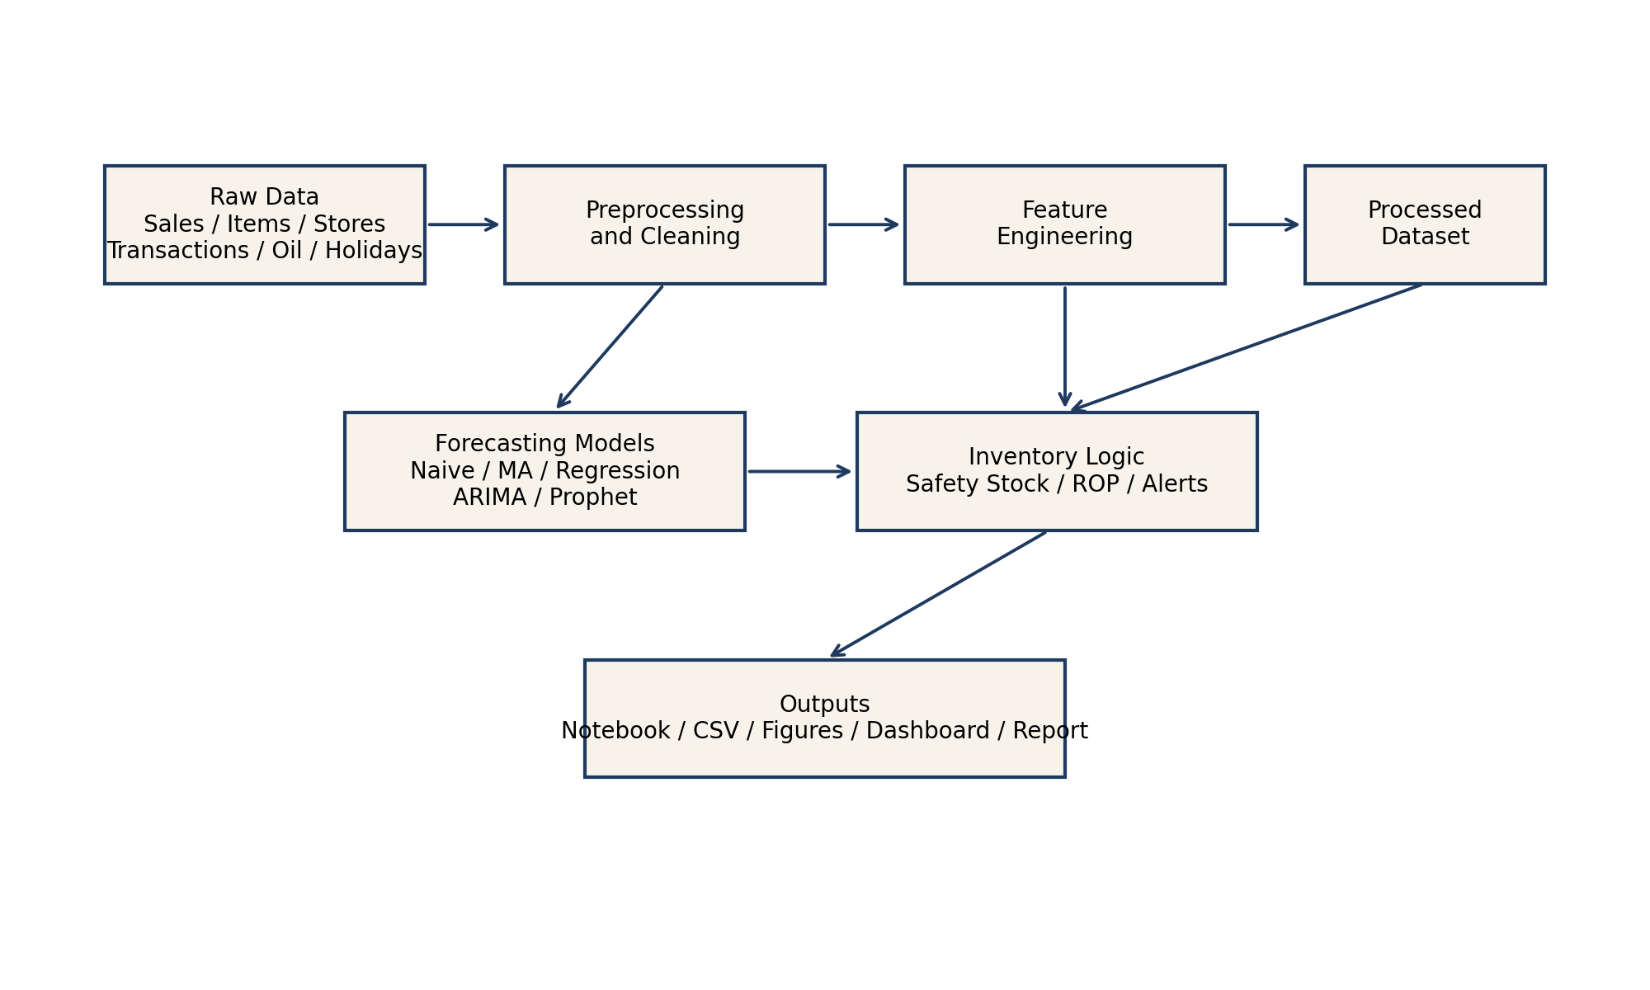

3.1 The Retail Forecasting and Inventory Optimization workflow consists of the following components:

A layered structure of the project is shown in figure 3.1, starting with the raw data files, followed by figures as output, CSV tables as output, the dashboard and the written report as output.
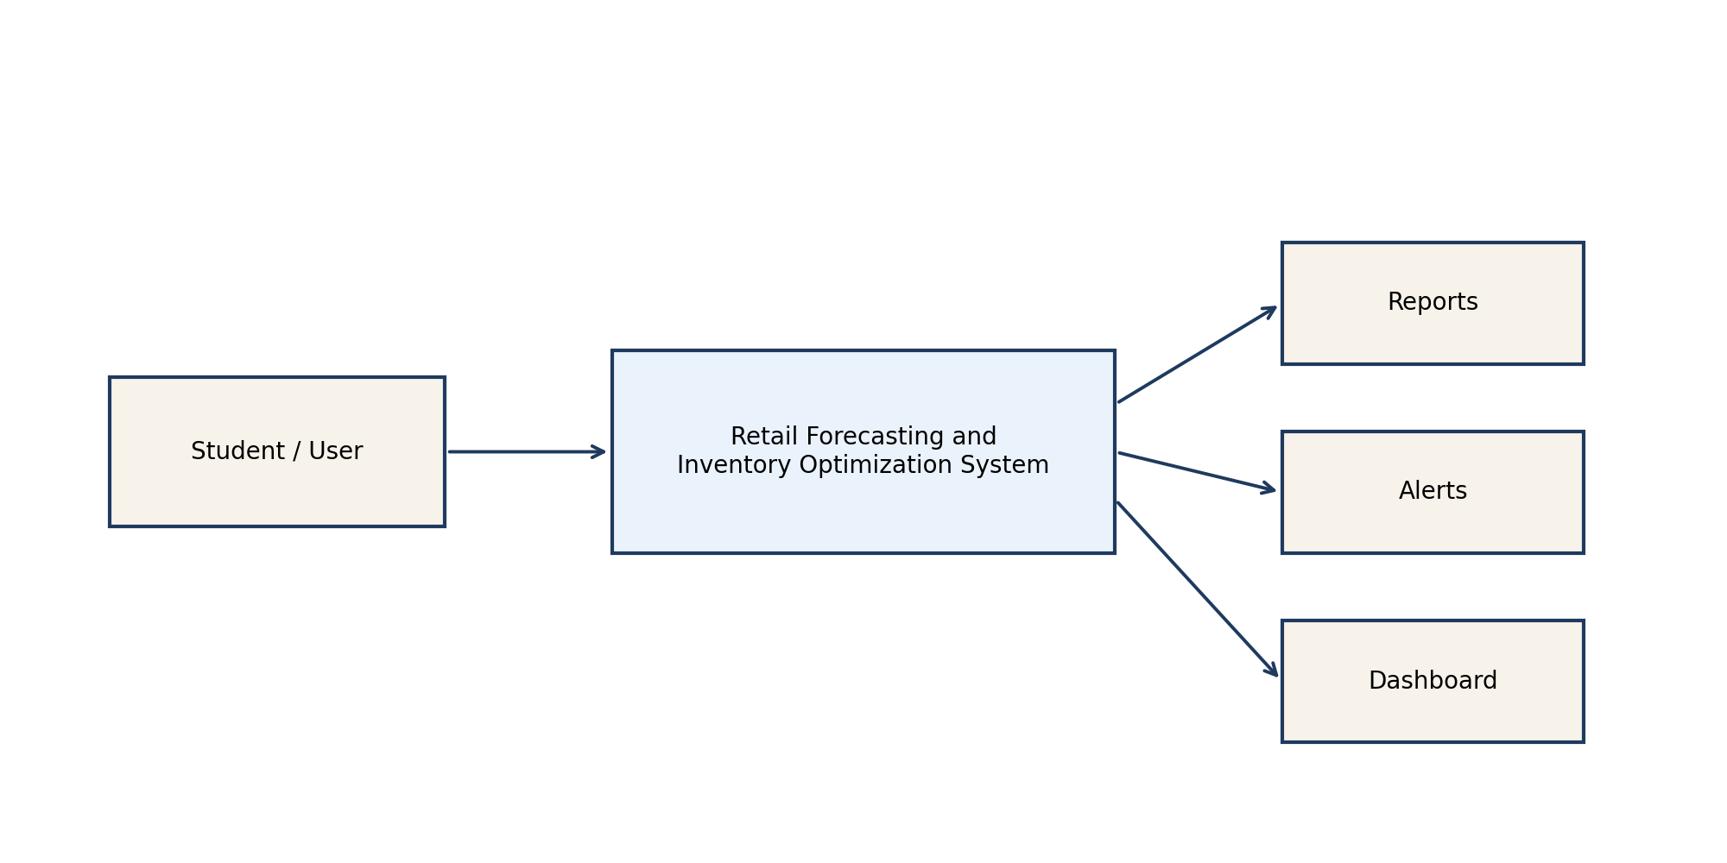
The proposed system DFD Level 0 is shown below in Figure 3.2.
The Level 0 DFD provides a high level user view of the system, and illustrates the products generated by the forecasting system including reports, alerts, and dashboard outputs.

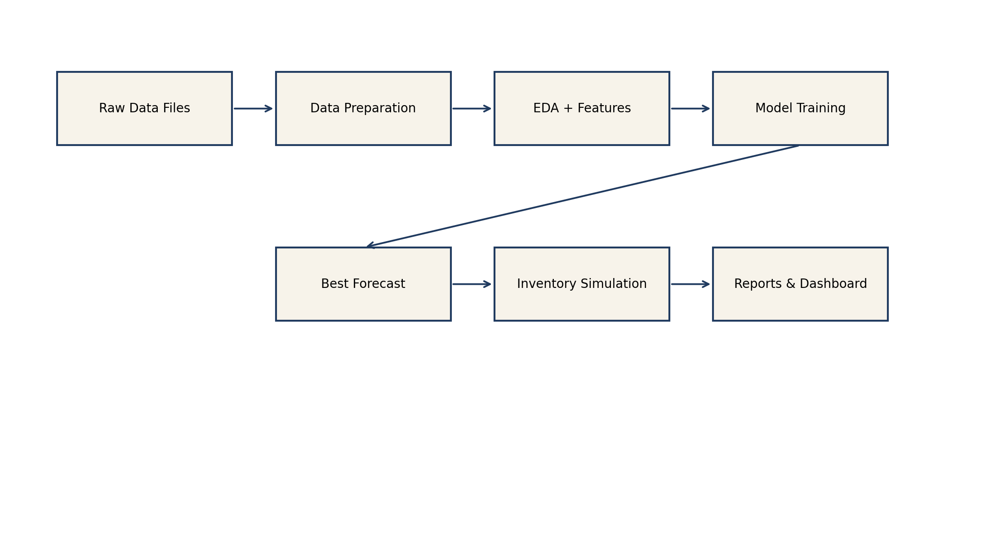
Figure 3.3: DFD Level 1 – showing the detail flow of processes
The Level 1 DFD adds the internal process path raw files to preprocessing, feature engineering, modeling, inventory simulation and the output of reporting.

4.5 UML and Data Design Diagrams

The project is not a transactional enterprise application, so the diagrams below highlight use cases, activities in the workflow, interactions between the modules, and the data relationships.

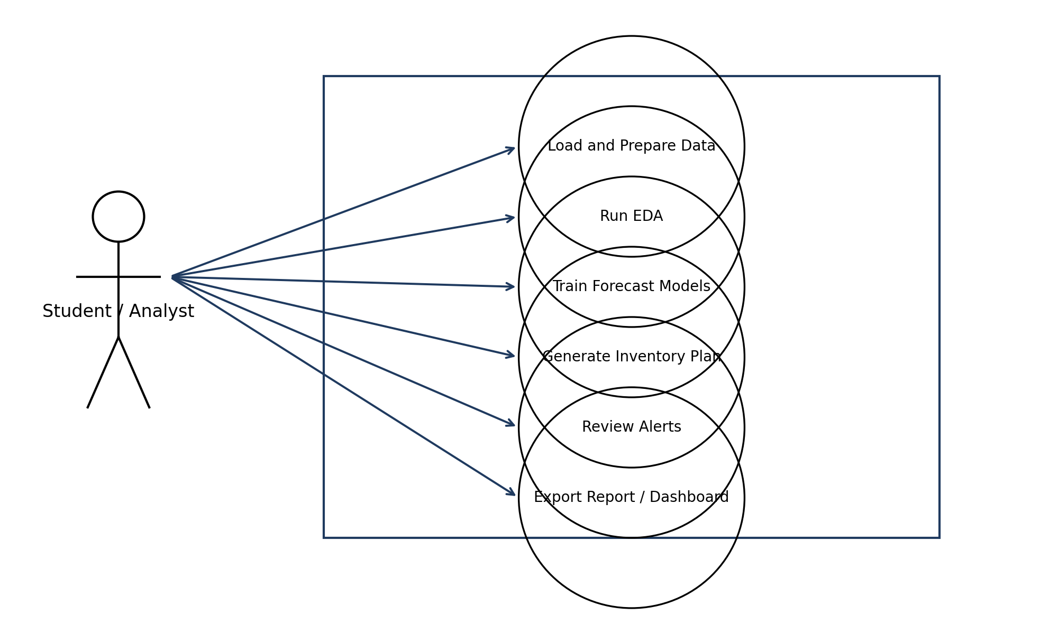
Use case diagram for the forecasting project (see Figure 4.1). The figure 4.1 shows the interactions that are available for the user of the analytical system, which involve the preprocessing, forecasting, inventory review, alert review and output export.

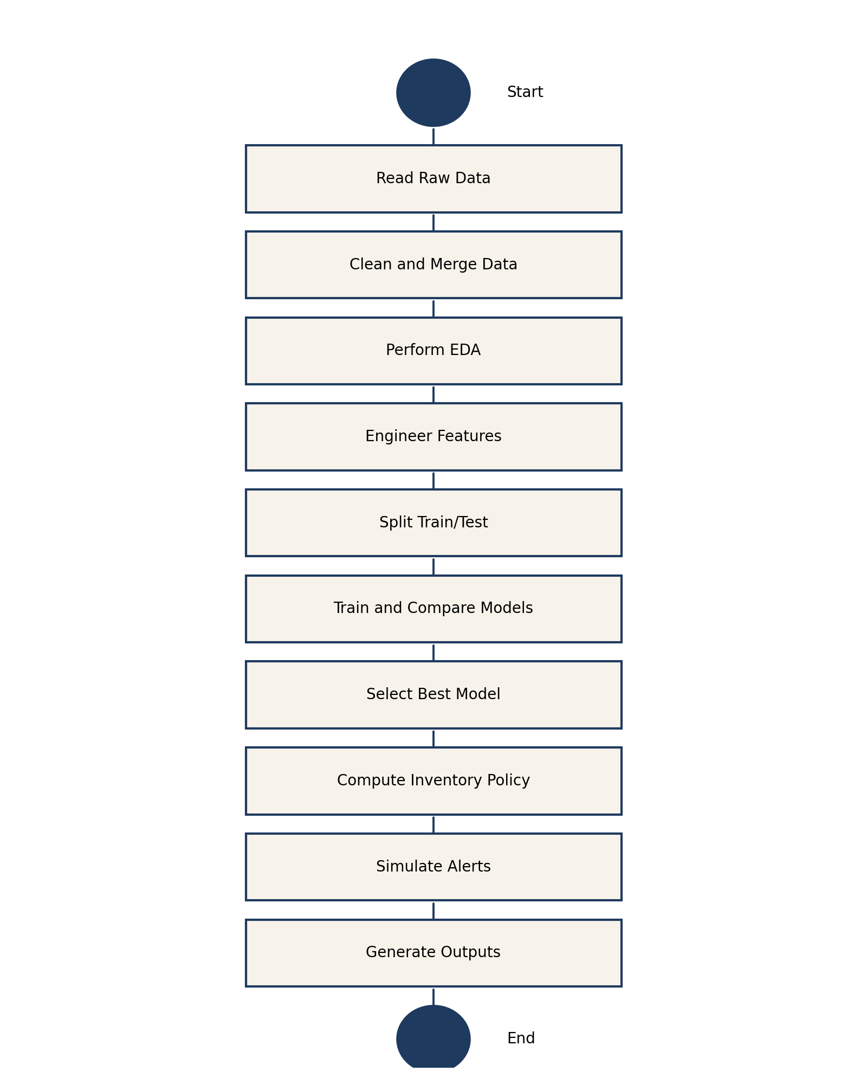

Activity diagram of the end-to-end workflow (figure 4.2). The activity diagram illustrates the project in the form of a decision-support workflow, moving from raw data to final products.

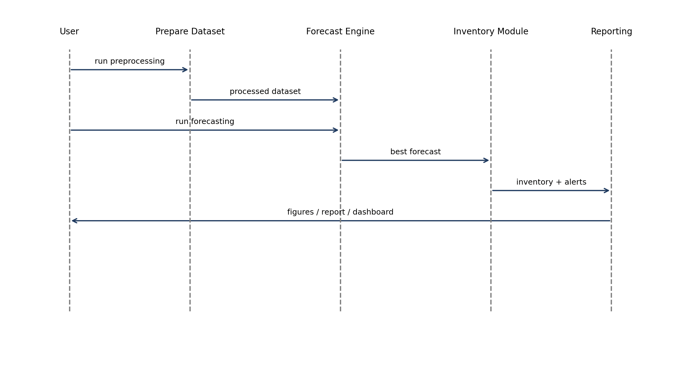

Figure 4.4: Parallel interaction between project modules The sequence-style interaction diagram represents how the user's action triggers the processing, forecasting, inventory and reporting phases throughout the system.

Data schema relationship of raw and processed files shown in Fig. 4.4. The data schema diagram gives you an overview of the raw CSV data sources, and how they feed into the processed analytical data set that is used for forecasting.

Table 6.1 Summary of key project test cases

Test Case ID | Input / Action | Expected Output | Actual Output | Status
TC-01 | Run preprocessing script | Processed dataset created | Processed dataset created | Pass
TC-02 | Load processed dataset | Required schema available | Required schema available | Pass
TC-03 | Run forecasting pipeline | Metrics table created | Metrics table created | Pass
TC-04 | Run inventory recommendation logic | Inventory table created | Inventory table created | Pass
TC-05 | Run simulation module | Alert and simulation files created | Files created | Pass
TC-06 | Export charts and dashboard | Visual outputs generated | Outputs generated | Pass

The student is required to produce Result Tables and Figures for this. The tables and figures below are a summary of the key quantitative and qualitative results of the current project run.

7.6 Result and Figures

Table 7.1: Forecasting model comparison metrics
model | mae | rmse | mape
linear_regression_lags | 229.492 | 290.328 | 17.86
prophet | 204.624 | 311.009 | 14.123
seasonal_naive | 231.963 | 405.221 | 13.945
arima | 318.317 | 496.427 | 24.793
moving_average_7 | 351.614 | 525.614 | 27.159

In the table above, the forecasting methods based on MAE, RMSE, and MAPE are compared. The operational forecasting model for the stock planning layer was chosen for the current run to be the lag-based linear regression model due to the lowest RMSE.

Table 7.2 consists of the result of the inventory recommendation from the forecasting model selected.
family is the value in the field.avg_daily_forecast is the average amount that will be sold per day for the family.

family | avg_daily_forecast | forecast_std_dev | safety_stock | reorder_point | recommended_order_qty
BEVERAGES | 2057.83 | 415.55 | 1814.1 | 16218.88 | 30623.65
DAIRY | 817.9 | 296.1 | 1292.61 | 7017.94 | 12743.27
GROCERY I | 2748.15 | 558.77 | 2439.3 | 21676.35 | 40913.41

Individual product families have different reorder policies as indicated in the inventory recommendation table. This is consistent with the rationale that it's better to have category-aware planning than a single uniform inventory rule.

Table 7.3 shows that current environment has access to advanced forecasting models.
model | available | note
seasonal_naive | True | Implemented locally as benchmark model.
moving_average_7 | True | Implemented locally as benchmark model.
linear_regression_lags | True | Implemented locally using lag and rolling features.
arima | True | ARIMA(7,1,1) fitted separately for each family.
prophet | True | Prophet fitted separately for each family with weekly and yearly seasonality.
lstm | False | tensorflow/keras is not installed in the current environment.

The following table lists the advanced models used during execution. It is added to ensure that the report remains technically balanced, as well as demonstrating that extensibility of the project design is possible even in the presence of runtime constraints.

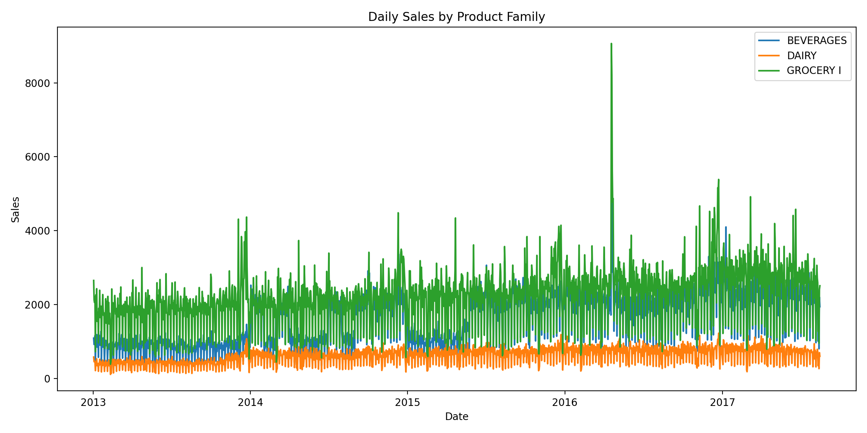
Figure 7.1 shows the daily sales history of the product families chosen. A longer term perspective of daily sales movement is shown in Figure 7.1. It reveals that there is a clear visual difference in the three families in terms of volatility and volume, further supporting the importance of forecasting logic that is family sensitive.

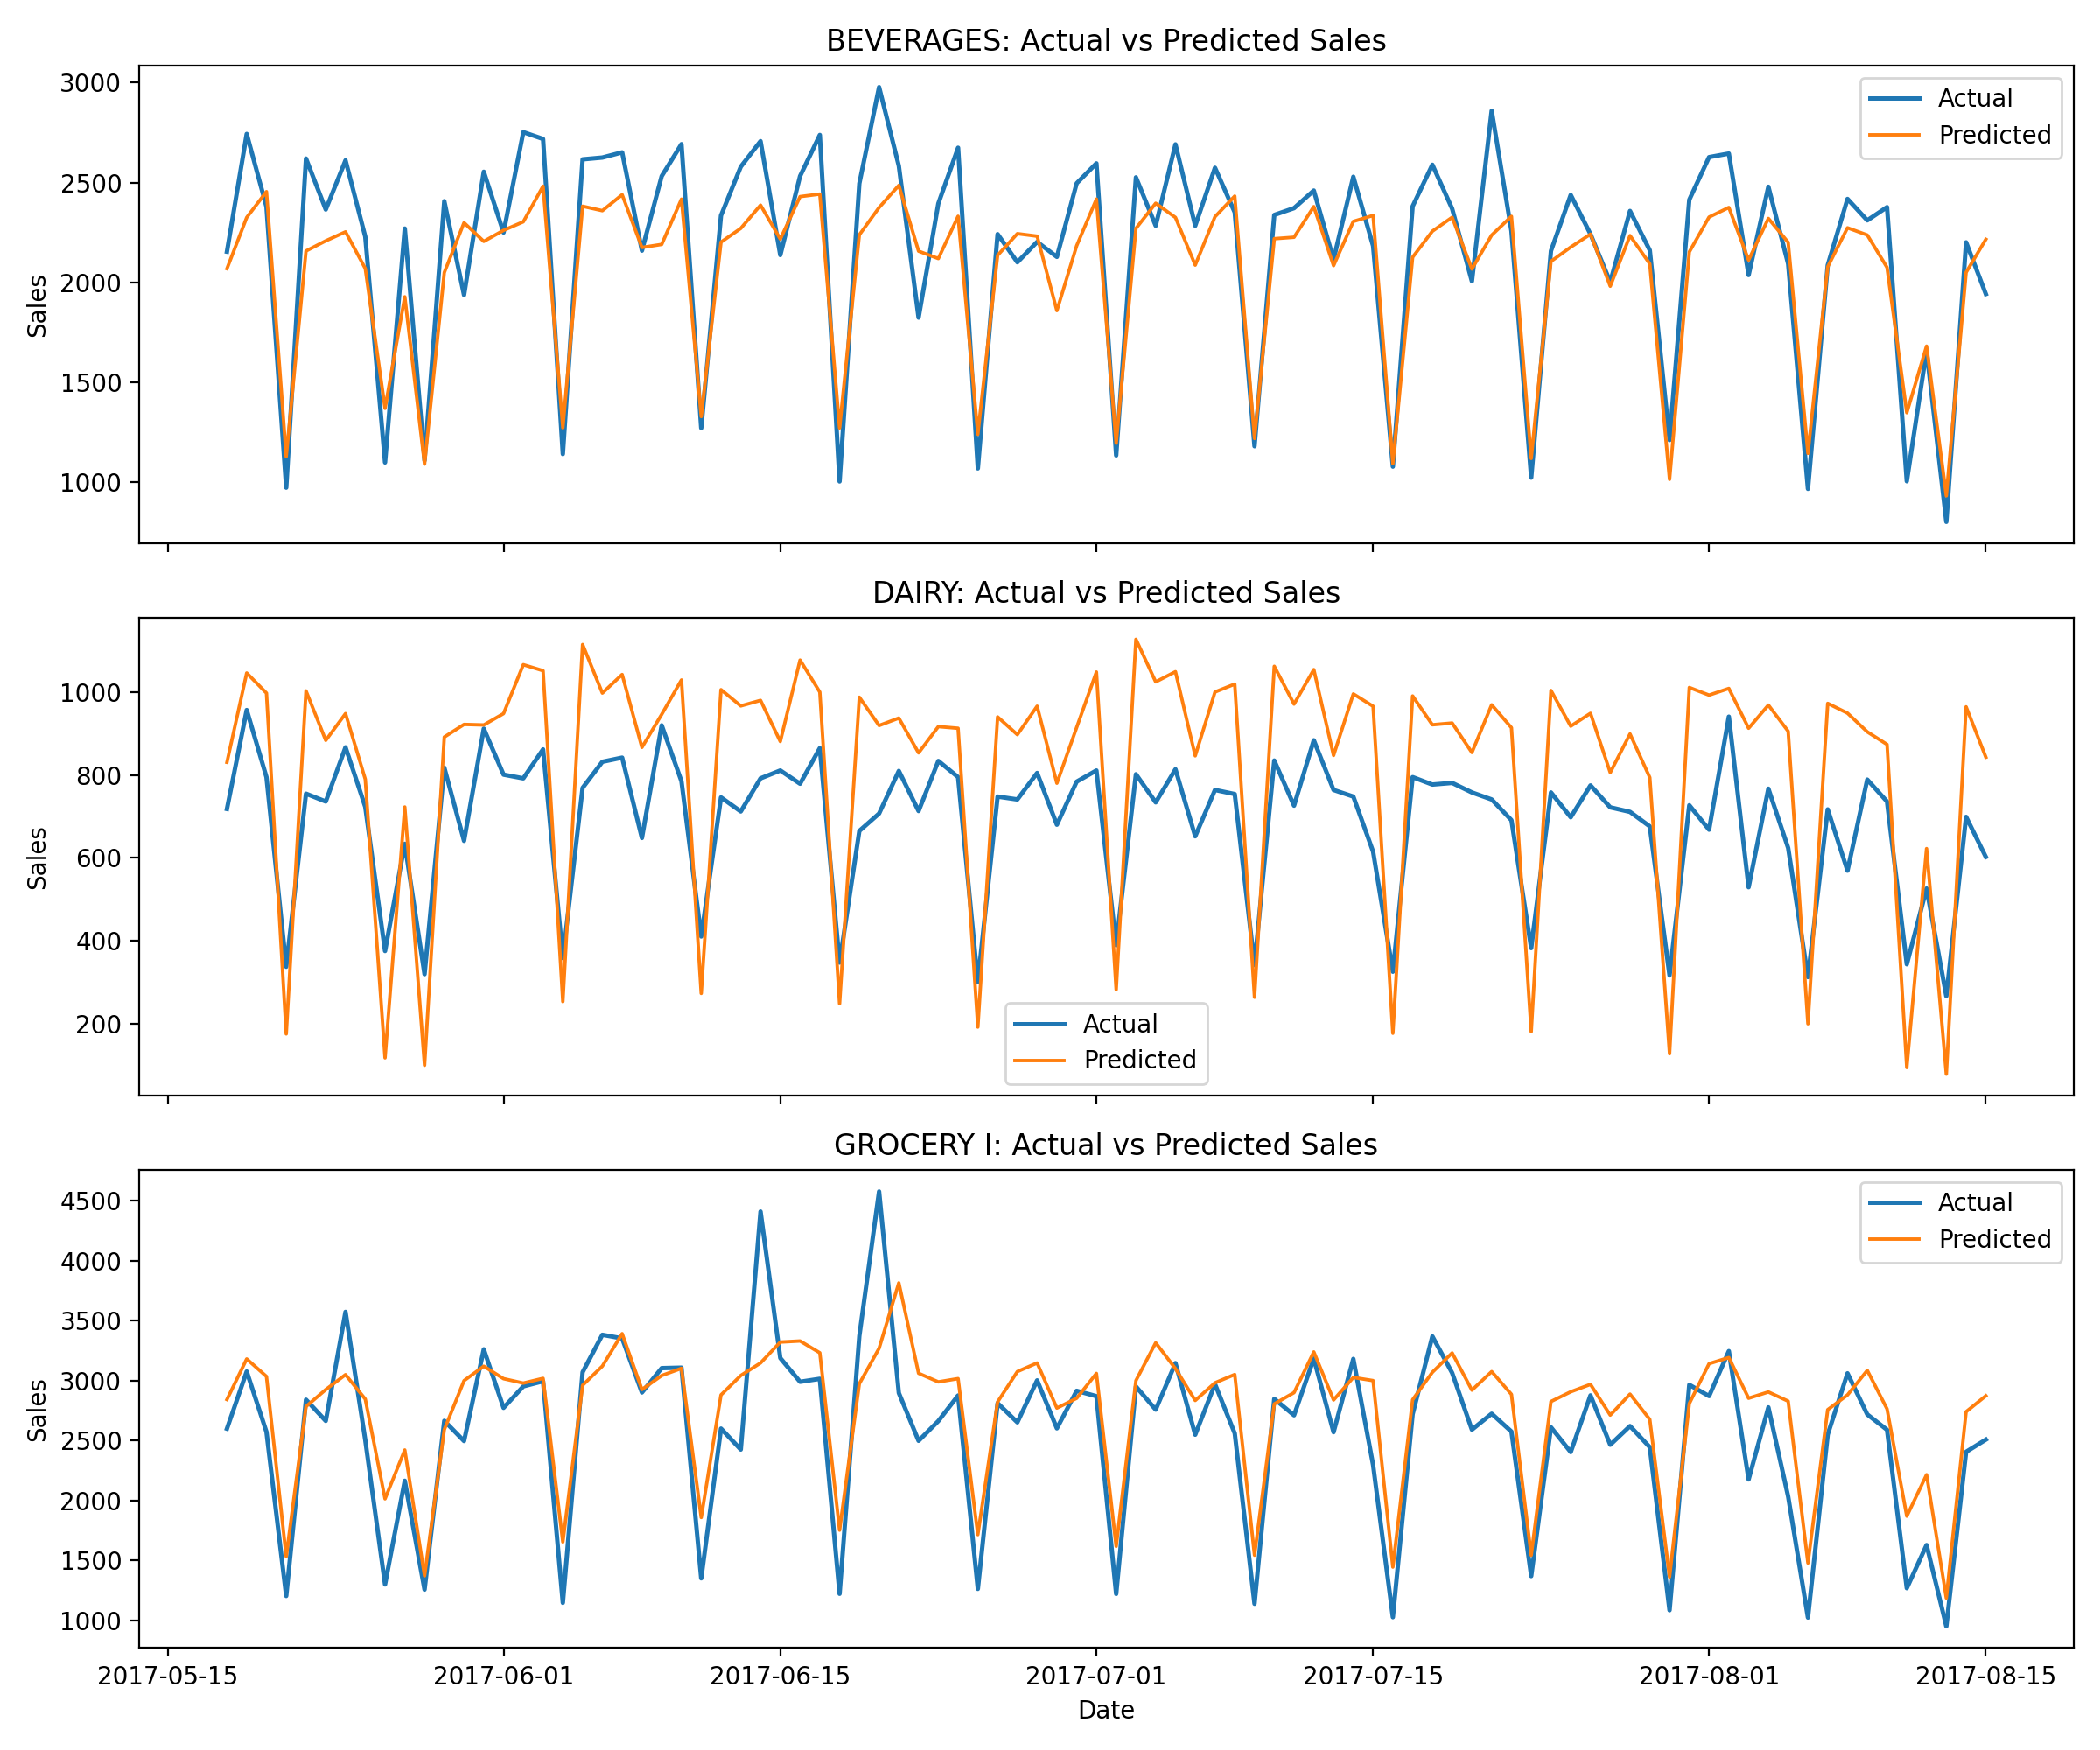
The observed and predicted sales are plotted against each other in Figure 7.2 for the model selected as the best one. The actual demand pattern is plotted in Figure 7.2 and compared with the chosen model, which is able to follow the actual demand pattern across the test horizon. The visual alignment is in addition to the quantitative finding using RMSE that the selected model is better than the tested ones.

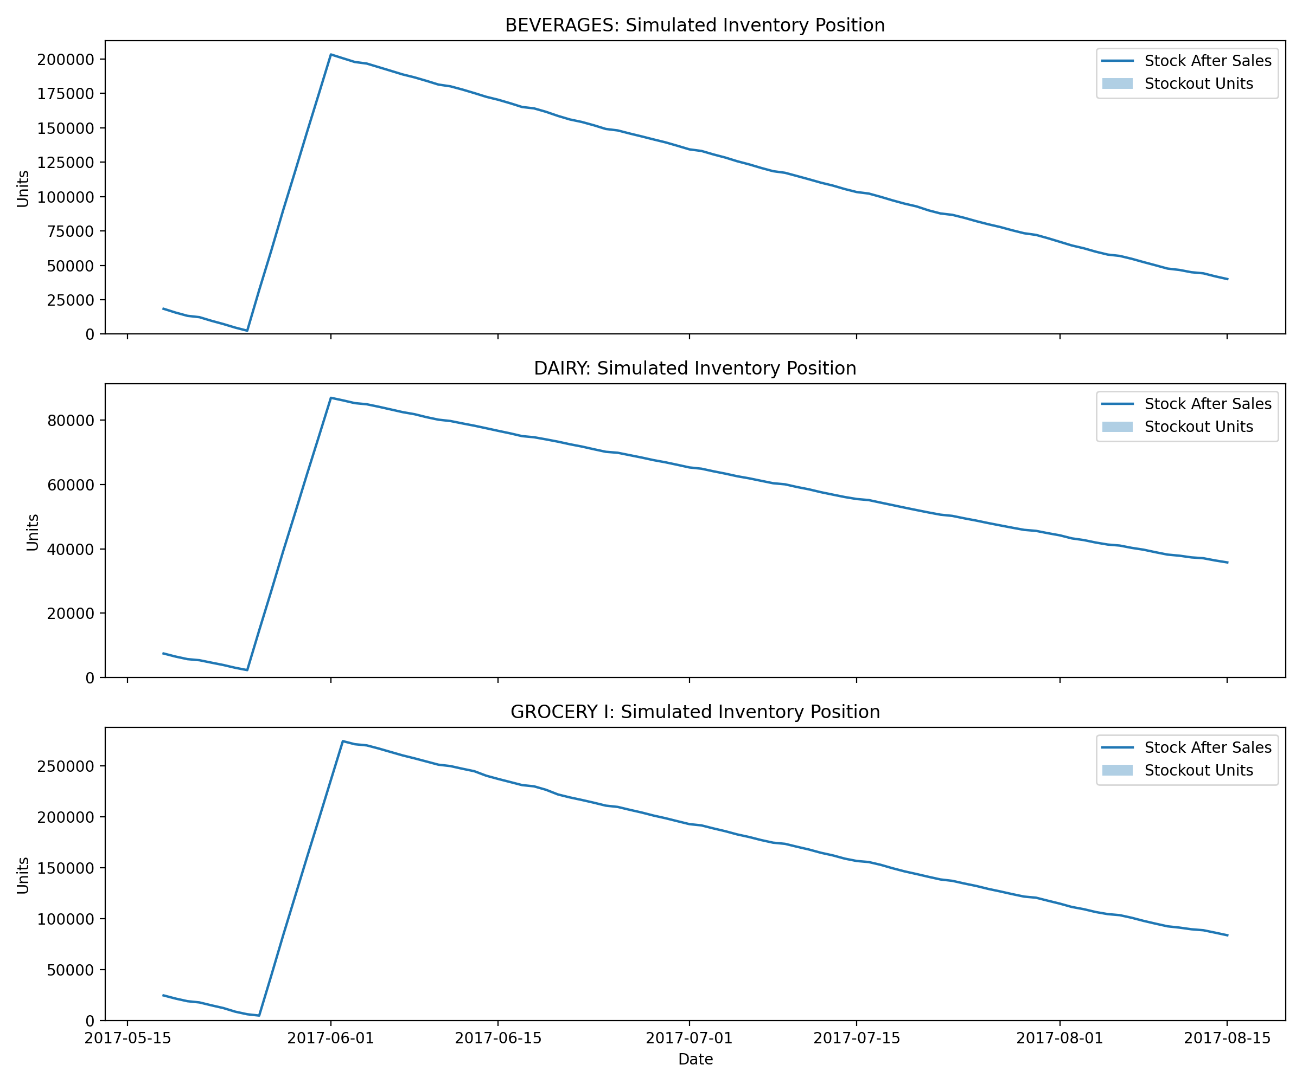
Figure 7.3: The number of stock movement in stocks and the number of stockout units during the test horizon.
Figure 7.3 shows the dynamic behaviour of the simulated stock policy. It offers an intuitive understanding of the interaction of reorder logic, demand consumption, and stockout risk, over time.

Chapter 9: References

Athanasopoulos, G. and Hyndman, R. J. (2021). Forecasting: Principles and Practice (3rd edition) OTexts. https://otexts.com/fpp3/
Hyndman, R. J. & Athanasopoulos, G. (2018). Forecasting: Principles and Practice (2nd Edition). OTexts. https://otexts.org/fpp2
Makridakis, S., Spiliotis, E., & Assimakopoulos, V. (2022). M5 competition: Background, organization and implementation. International Journal of Forecasting, 38(3). https://doi.org/10.1016/j.ijforecast.2021.07.007
S. Makridakis, E. Spiliotis, and V. Assimakopoulos (2022). M5: Accuracy Competition Results, Findings and Conclusions. International Journal of Forecasting, vol. 40, issue 3, 2021, p. 846-855. https://doi.org/10.1016/j.ijforecast.2021.11.013
Makridakis, S., Petropoulos, F., & Spiliotis, E. (2022). Conclusions - M5 competition. International Journal of Forecasting, 38(4). https://doi.org/10.1016/j.ijforecast.2022.04.006
Taylor, S. J., & Letham, B. (2017). Forecasting at scale. PeerJ Preprints. https://doi.org/10.7287/peerj.preprints.3190v2
Pandas Development Team. (2026). pandas documentation. https://pandas.pydata.org/docs/
NumPy Developers. (2026). NumPy documentation. https://numpy.org/doc/stable/
Matplotlib Development Team. (2026). Matplotlib documentation. https://matplotlib.org/stable/
Python Software Foundation. (2026). Python documentation. https://docs.python.org/
Project Jupyter. (2026). Documentation for Project Jupyter.
Kaggle. (n.d.). Data set on forecasting grocery sales for Corporación Favorita. https://www.kaggle.com/datasets/ruiyuanfan/corporacin-favorita-grocery-sales-forecasting
He, W., Liu, P., & Qian, Q. (2023). Case Study: Corporación Favorita: Forecasting Grocery Sales. In Machine Learning Contests: A Guidebook. https://doi.org/10.1007/978-981-99-3723-3_11
Brahmantyo, R. A., Wibowo, J., & Nurcahyawati, V. (2023). Manajemen Persediaan dengan Metode Safety Stock dan Reorder Point. Jurnal Sains dan Informatika. https://doi.org/10.34128/jsi.v9i1.431
Mubasysyir, M. H., Supian, S., & Hertini, E. (2024). Application of multi item inventory control model with economic order quantity, safety stock and reorder point in retail business. This work was published in the International Journal of Global Operations Research, an open access journal. https://doi.org/10.47194/ijgor.v5i1.237
Statsmodels Developers. (2026). statsmodels documentation. https://www.statsmodels.org/
Prophet Developers. (2026). Prophet documentation. https://facebook.github.io/prophet/
TechTarget. (2024). Systems Development Life Cycle is what? https://www.techtarget.com/searchsoftwarequality/definition/systems-development-life-cycle
Universidad Internacional de Andalucía. (2018). Corporación Favorita Grocery Sales Forecasting. http://hdl.handle.net/10334/3921
Fickincool. (2025). store_sales_forecasting. GitHub. https://github.com/Fickincool/store_sales_forecasting

Chapter 10: Appendices

Appendix A: Source Code Structure

The project is divided into the following layers: Preprocessing, Forecasting, Advanced modeling, Inventory, Reporting, and Notebook explanation. These elements should be fixed (or cited) to the final submission as proof of source code.

Appendix B : A list of output files.
• reports/tables/model_metrics.csv
• reports/tables/model_availability.csv
• reports/tables/inventory_recommendations.csv
• reports/tables/inventory_simulation.csv
• reports/tables/stock_alerts.csv
• reports/figures/sales_history.png
• reports/figures/best_model_forecast.png
• reports/figures/inventory_simulation.png
• reports/dashboard.html

The User Manual is attached as Appendix C.

16 . Execute the preprocessing script to run the preprocessing process on the raw source files to generate the processed dataset.
17. Execute the main forecasting pipeline and generate the metrics, figures, recommendations and dashboard output.
18. Open the notebook to review stepwise analysis and explanations.
19. Utilize the tables and figures created and use them when creating the final report and presentation.

The Appendix D:
21. Installation Guide is a document that contains installation instructions.
22. Set up the project's Python and necessary libraries.
23. Store the data files in the anticipated project folder structure.
24. Execute the scripts sequentially, from pre-processing to finally reporting.
25. After opening the document, update field in the Microsoft Word document to refresh table of contents and list sections.

